CSS (cascading slide sheets)

* In css1, some modules like font, and color were introduced.
* In version 3, they said we no longer add to the version because we may have inconsistencies in different browsers.
* So it stopped at css3, and from there, everything new was added as modules. In css3, they made levels instead of versions. And browsers can support these levels if they want to.
* Selectors were introduced in css2. For example, some features may be added to selectors; we call them level 4 selectors.
* Some features were added to media queries as level 4 in 2017.

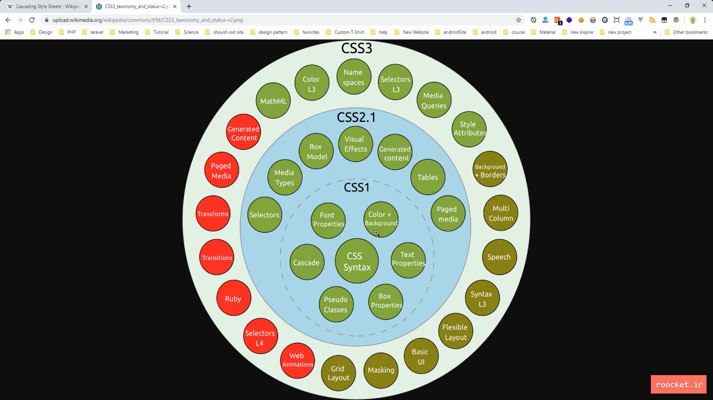

* Browsers implement and render CSS in their particular way. To know what browser uses what css level module, see <developer.mozilla.org> and <https://caniuse.com/>
* /* */ Comments : ctrl + /
* **user-agent stylesheet** // default style values of browsers

## Ux/Ui layout designer:

* Photoshop, Adobe XD, Sketch
* <https://nicepage.com/sd/69325/interactive-learning-website-design> // support Persian
* <wix.com>
* <https://kamva.ir/>

## How to use css

* + **Inline css** // on the tag
  + **Internal** <style></style. in head tag // selectors
  + **External** <link rel="stylesheet" href="">
  + Use selectors
  + Use properties

## Selector priorities

* More specified // More chain of selectors
* In order of writing // last linked CSS file have higher priority

## CSS property inheritance

* If the mother tag has a style that the child doesn't, the child inherits that style.

## Webkit and moz

* **-moz-property** // **firefox** 19 forward
* **-Webkit-property** // webkit engine is used for **chrome**, **opera**, **safari**

::-webkit-input-placeholder

* **Ext: css-auto-prefix** // automatically add the prefixes

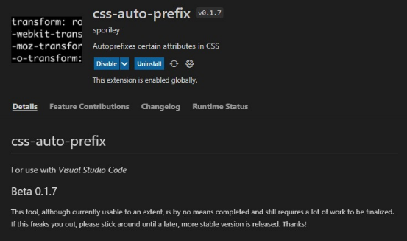

selectors

* **.class { }** // an element can have more than one class, and every class can be used for multiple elements
* **#id** // just one for an element and is used for only one element
* **\*** // selects all elements

#nav * { font-size: 20px } // selects all children of any level (all elements inside element with id nav)

* **:not()**

input:not([type = "checkbox"]){ }

## Multilevel and dependent selectors

* **.class1.class2, #id.class1, div.class1** //no space between classes (or combination of id and classes), it means an element that has both of these classes
* **div .class1** // children of any level

## attribute selectors

* **[ ]** // all attributes can be selected, [id=""], [class=""], [href=""]
* **a[href="url"]{ }**
* **a[href*="example"]** //all links that have an example in their href. Star searches the href attribute and if the value is found, selects that link.
* **a[href$="org"]** //$ searches the end of the href string

<ul>

<li href="http://example.com"><a>link1</a></li>

<li href="http://example.org"><a>link2</a></li>

</ul>

* **li[class="item"]** // if the class string is identical to "item", for example, the li below will not be selected.

<ul>

<li class ="item item1" href="http://example.com"><a>link1</a></li>

<li href="http://example.org"><a>link2</a></li>

</ul>

* **li[class~="item"]** // if the item was found in classes, ~ checks if a class exists in the list of classes. Is used to select elements with an attribute value containing a specified word.

## CSS combinators

* why should we use them? For example, in JavaScript, we want to select an element based on (related to) another element, taken, for example, by an event.
* **el > el2** // direct child
* **el + el2** // sibling right after, el2(classes, tags names …) that is a sibling of el and comes right after it. .item + .item means items with .item class that have a sibling after that has .item class, it can be used to give margins.
* **el ~ el2** // el2 is a sibling that comes after el, not necessarily right after. Any sibling after el that matches el2.

## Pseudo-classes

[CSS Reference](https://developer.mozilla.org/en-US/docs/Web/CSS/Reference)

* It takes the different states of an element to style that state.
* **:hover**

li:hover a{

lolor:white;

}

* **:first-child**
* **:root** // It is aCSS pseudo-class matches the root element of a tree representing the document. In HTML, :root represents the <html> element and is identical to the selector html , except that its specificity is higher.

## Pseudo element

* Selects some part of the element
* **::after**
* **::before**
* **::placeholder**
* **::first-letter**
* **::first-line**
* **content: "ListItem"** // content is a property name specific to pseudo-elements. It takes a text or character.

li::before{

content : "ListItem"

color: blue

}

p::first-letter{

font-weight : bold

}

Box model

* The box model is made from a different level and specifies the space that all elements occupy.

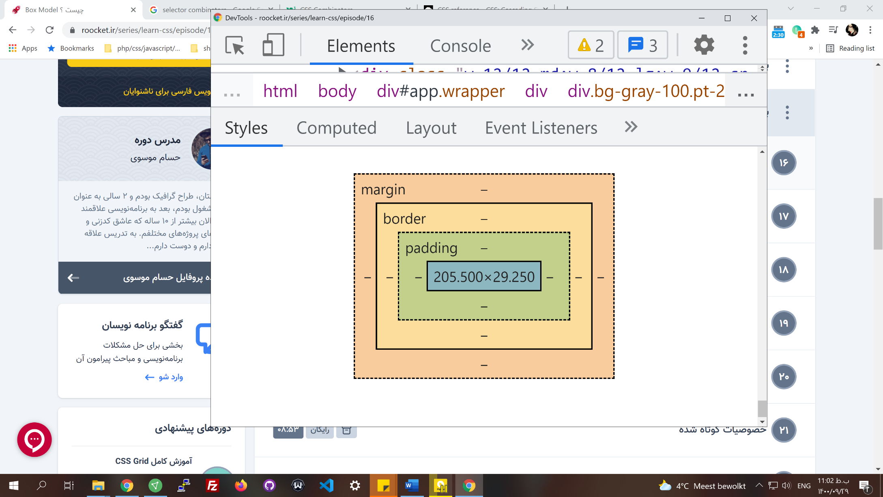

Width height

* **padding-top,** padding-right, padding-bottom, padding-left

padding: 10px 20px 24px 10px; //**short-hand** version

padding: 10px 20px;

**padding: 10px 20px 30px;** // you can set the bottom separately, left and right would be 20px

padding: 10px

* **border-top,** border-right, border-bottom, border-left, border-width, border-style, border-color
* **margin-top,** margin-right, margin-bottom, margin-left

width, height, max-width, min-width // min-width says don't become smaller than this. Meaning that if you have a div with min-widht: 800px; in screen sizes bigger than 800 it will cover the whole width. In smaller screens, it keeps the width 800px (screen becomes scrollable).

* **box-sizing:** border-box, content-box // border-box says the border is included in the width.

## CSS reset

* every browser loads some default styles for specific elements. For example, p has margins.
* For the first part, we can use * { }, but the below is more specific.
* It's better if we create a separate CSS file for CSS reset. (reset.css)

html, body, div, span, applet, object, iframe,

h1, h2, h3, h4, h5, h6, p, blockquote, pre,

a, abbr, acronym, address, big, cite, code,

del, dfn, em, img, ins, kbd, q, s, samp,

small, strike, strong, sub, sup, tt, var,

b, u, i, center,

dl, dt, dd, ol, ul, li,

fieldset, form, label, legend,

table, caption, tbody, tfoot, thead, tr, th, td,

article, aside, canvas, details, embed,

figure, figcaption, footer, header, hgroup,

menu, nav, output, ruby, section, summary,

time, mark, audio, video {

margin: 0;

padding: 0;

border: 0;

font-size: 100%;

font: inherit;

vertical-align: baseline;

}

/* HTML5 display-role reset for older browsers */

article, aside, details, figcaption, figure,

footer, header, hgroup, menu, nav, section {

display: block;

}

body {

line-height: 1;

}

ol, ul {

list-style: none;

}

blockquote, q {

quotes: none;

}

blockquote:before, blockquote:after,

q:before, q:after {

content: '';

content: none;

}

table {

border-collapse: collapse;

border-spacing: 0;

}

Background-image

* **background-color: red**
* **background-image: URL ()** //URL is something like a function. It gets the image to show it in the selected element. You should set the height and width for it, or it won't appear on the screen. If we have a background color and image, the image always comes in front of the color (has higher priority).
* **background-size: width height** // values: width height, content, cover,
* **background-repeat: no-repeat** // the default value is **repeated.** Values: repeat-y, repeat-x.
* **background-position: x y;** // position is a short-hand of x and y; numbers can be negative. Positive x pushes the image to the right, and y pushes the image from the default position (right top corner of div) to the bottom. If the number is negative while using a percentage, it will push it to the bottom. Also, you can define the top, bottom, left, and right.

background-position: left(or right) 0 top(or bottom) -200

* **background-origin:** // using a border, on a div with background-image, causes problems as shown below in the picture. The background color is shown on the border left and right. Like box-sizing, it has some values:
  + **padding-box** // it gets the padding level box size
  + **border-box** // helps with the issue below. It doesn't consider the border in how to set the background. It brings the border over the background. It sets the background on border-level box size.
  + 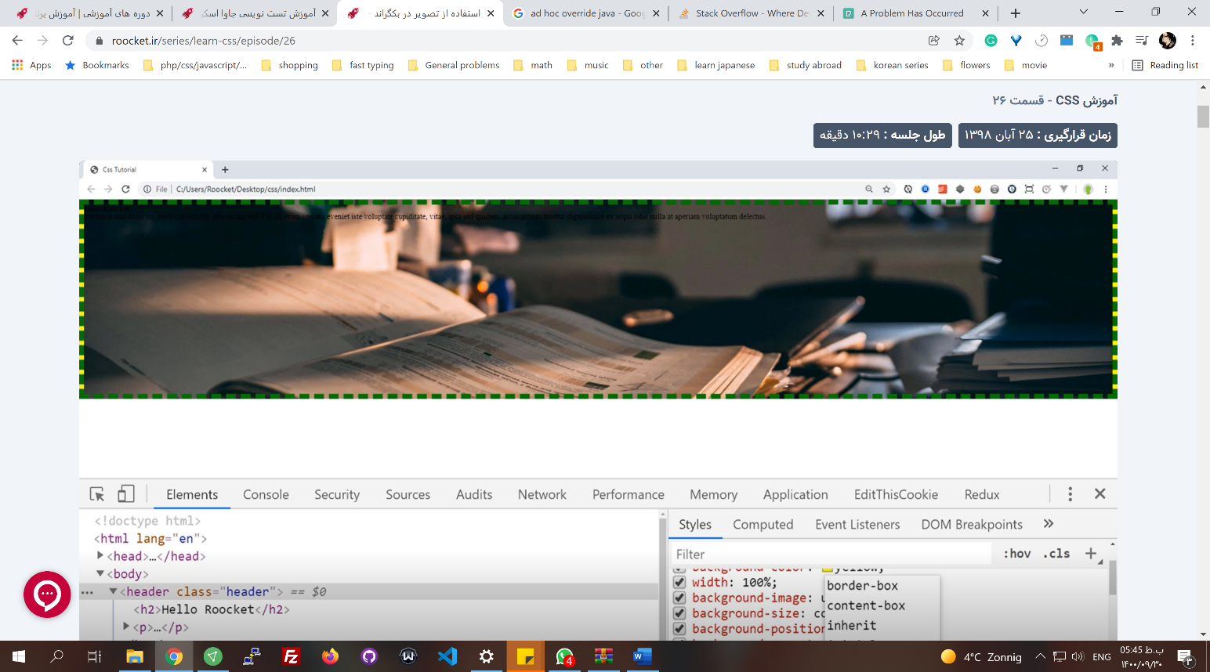**Content-box** // the last level box size (height and div of the element)
* **background-clip:** 
  + **content-box** // clip(cut) only the content level - show only the content (background between content and border will not be shown)

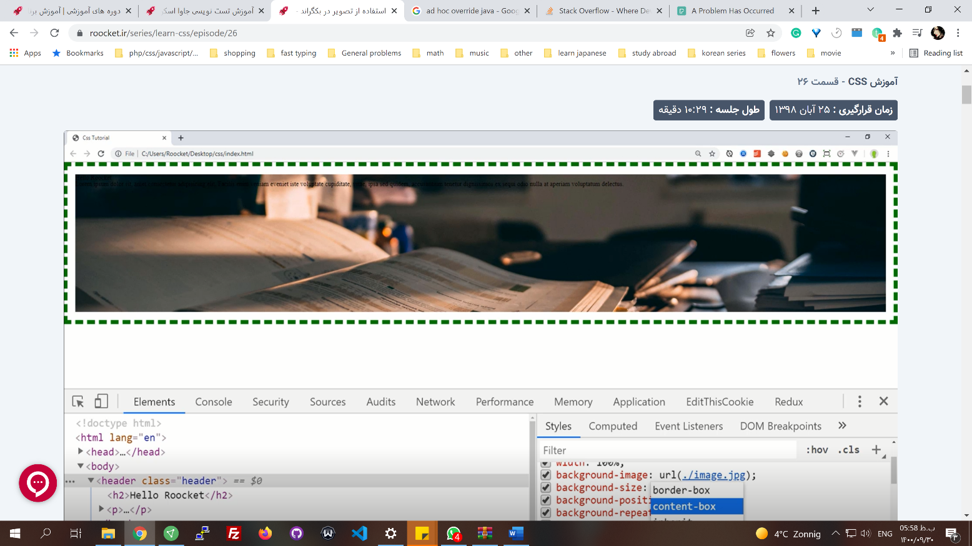

Content area

* + padding-box
  + border-box
* **background-attachment: fixed** // on the scroll the image keeps its position. In other words, **always the same part of the image is shown**.

## Short-hand background

* **background:""** // is a short-hand property that has some other properties combined. [background](https://developer.mozilla.org/en-US/docs/Web/CSS/background)

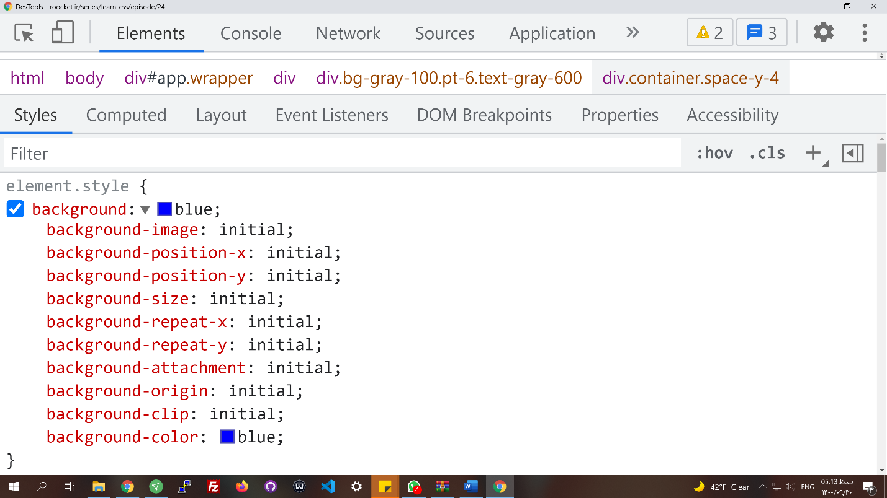

* background: url() **x y/size** repeat origin clip attachment color // position and size should always be used together( position/size ), everything else can have different orders.

background: url(./image.jpg) no-repeat; // this is possible, browser can understand it based on the values given.

background: url(./image.jpg) 0 20%/cover no-repeat border-box fixed red// border box is set for both origin and clip

## Linear gradient

* **background: linear-gradient(red, blue)** // if you give two parameters, make a gradient from top to bottom, red top, blue bottom.
* **background: linear-gradient(red, blue, green, black, yellow, …)**
* **background: linear-gradient (to right, red, blue, green)**
* **background: linear-gradient(236deg, red, blue, green, …)**
* **background: linear-gradient(236deg, red, blue 50%, green, black)** // paint red and blue for 50%
* **background: linear-gradient(236deg, red, blue 50%, green 90%, black**) // paint red and blue for 50%, then from 50% to 90% paint green, and the rest colors would be 10%
* **background: linear-gradient(236deg, red, blue 60%, green)**

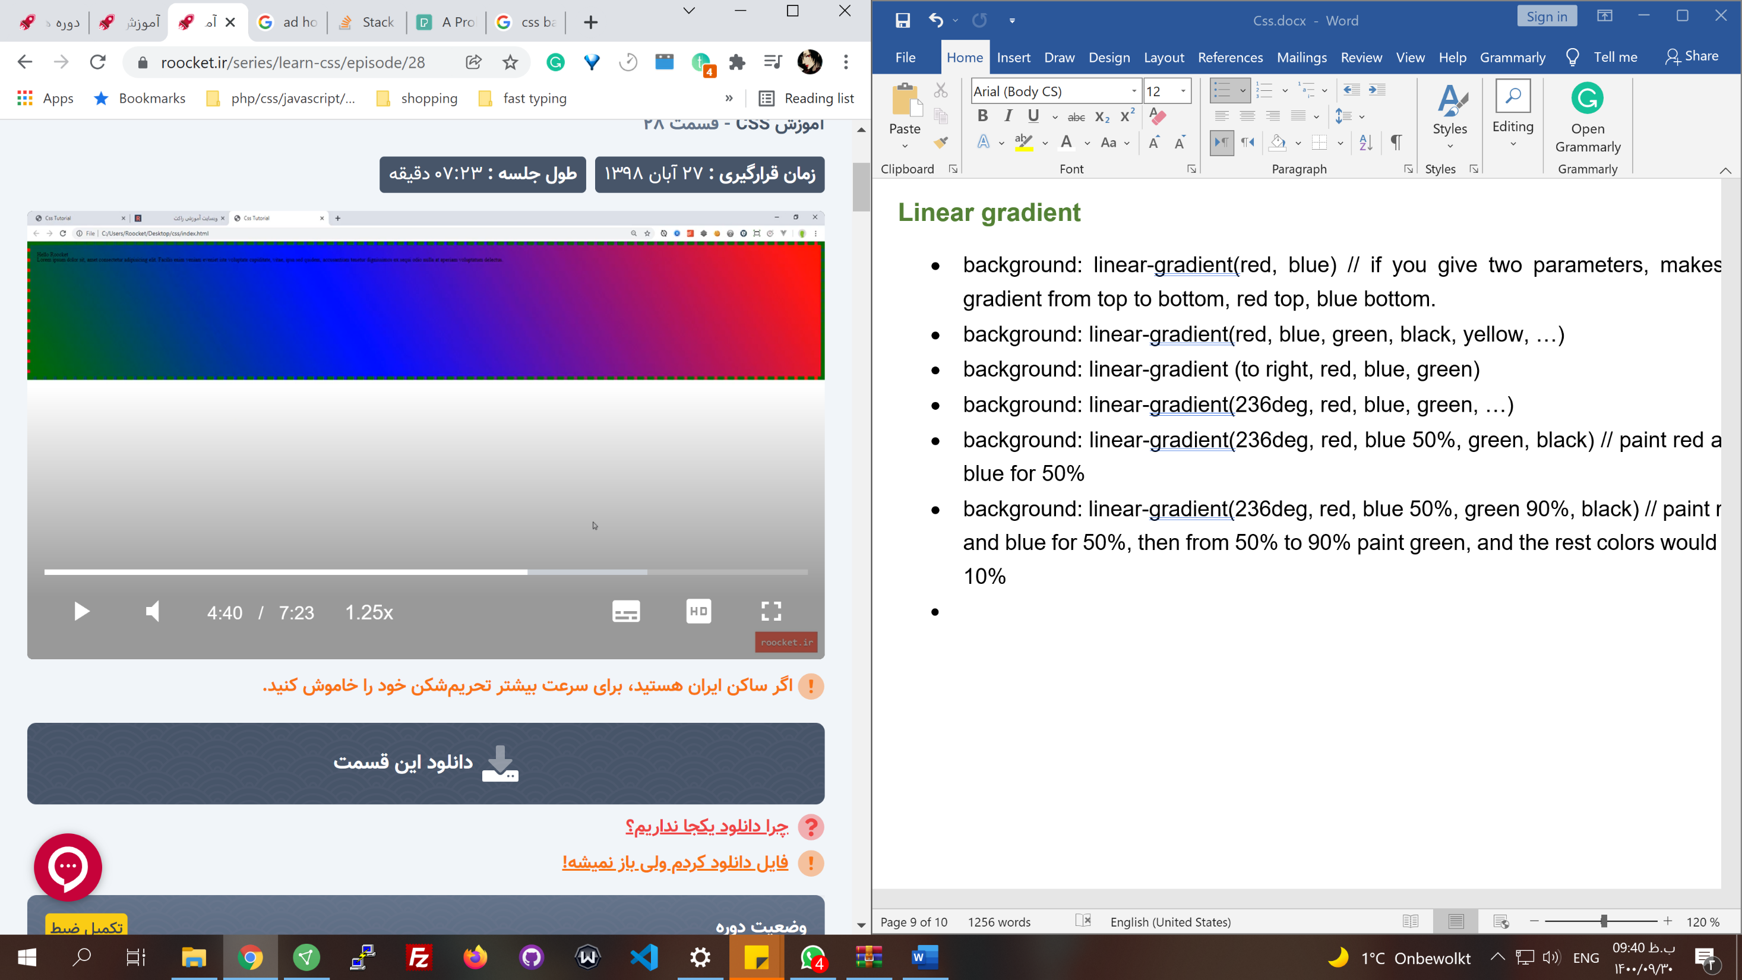

60%

40%

**Create a stop line between grandients**

* Give some free space in between // look at difference between precentages.

background: linear-gradient(119deg, #ff0000 40%, #ffffff 30%);



## Radial gradient

[radial-gradient()](https://developer.mozilla.org/en-US/docs/Web/CSS/gradient/radial-gradient())

* It is in a circular direction
* **radial-gradient (blue, green)** // in circular, from blue to green from center

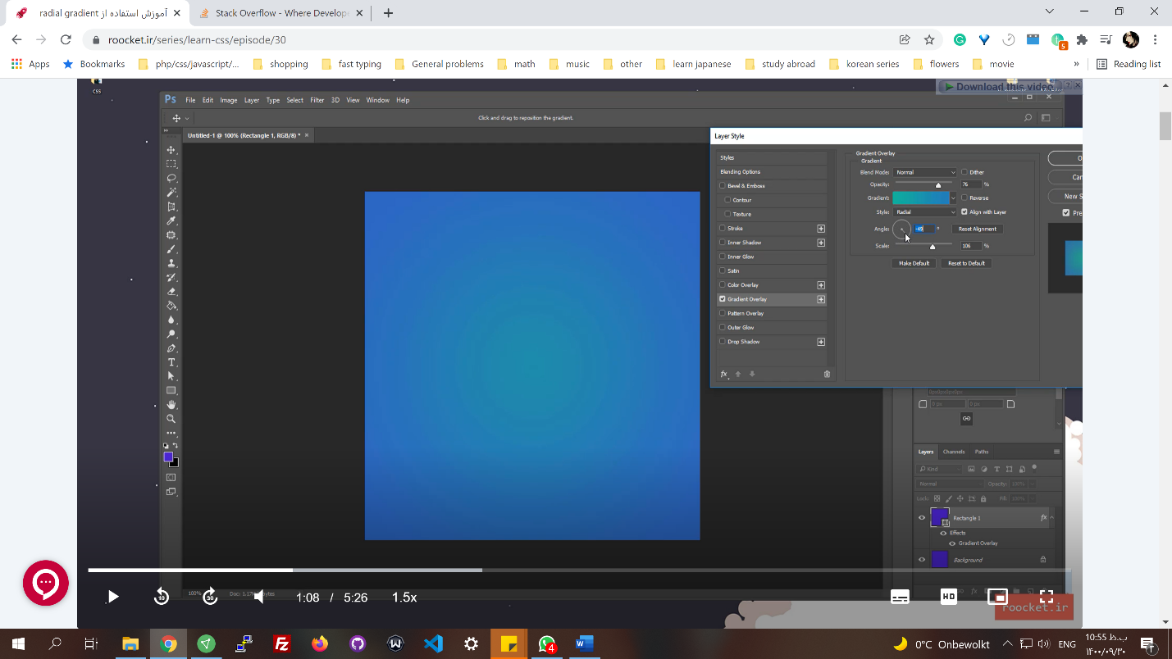

* **background: radial-gradient(circle at center**); //radial-gradient (red, blue) does the same thing, in default it is a circle at the center.
* **background: radial-gradient(direction, colors %)**

background: radial-gradient(ellipse at top, #e66465, transparent),

radial-gradient(ellipse at bottom, #4d9f0c, transparent);// ellipse means بیضی

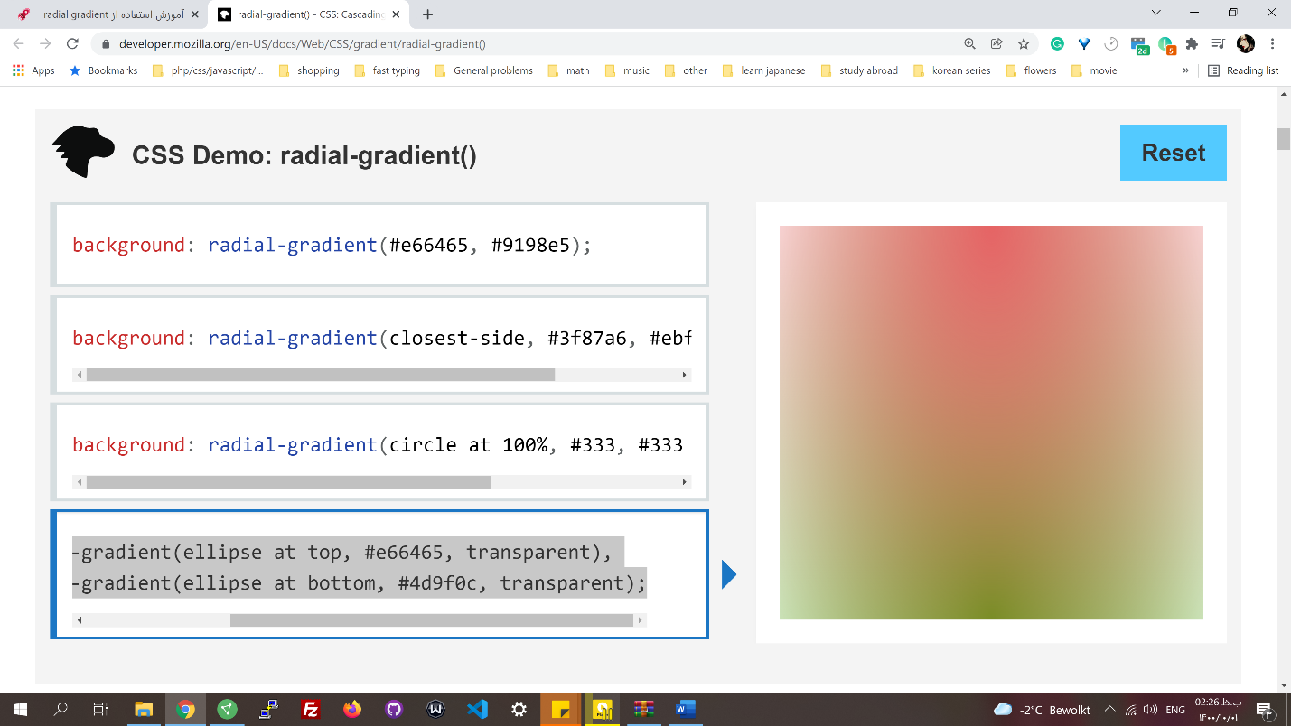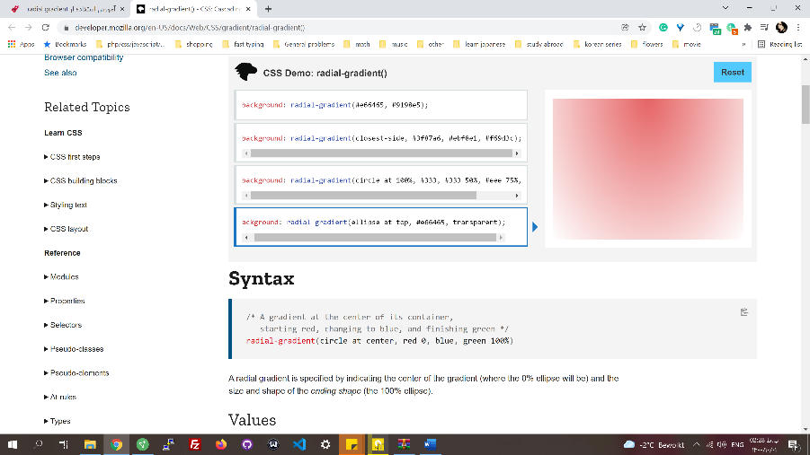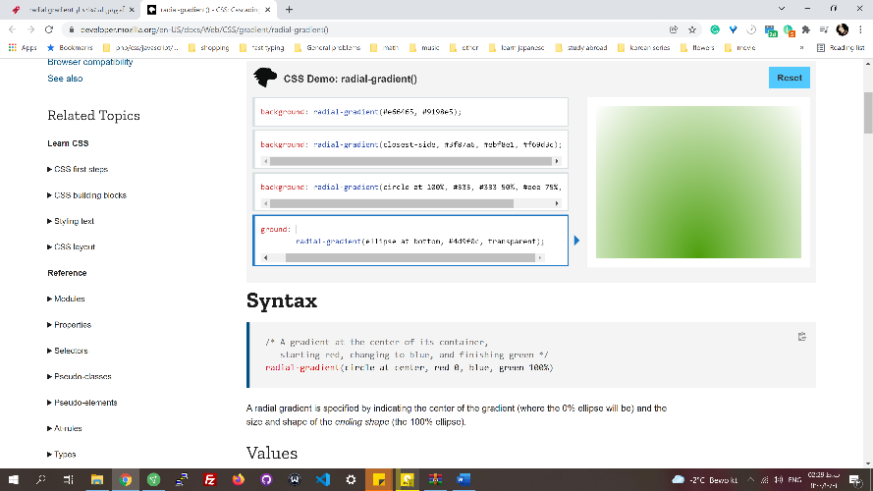

First gradient

Second gradient

Colors

* How to define colors?

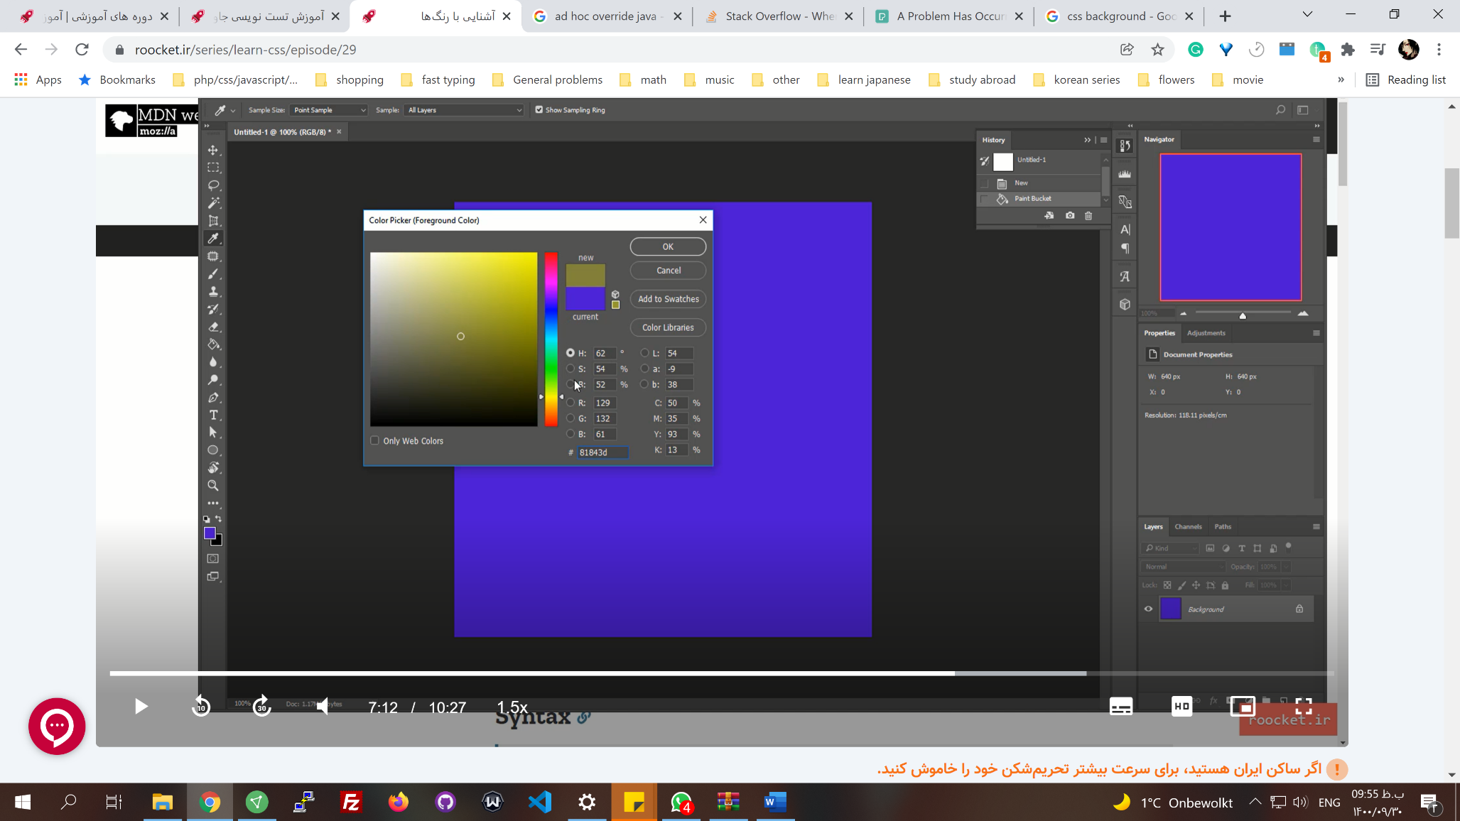

x,y in hsl

z

* names: red, blue, green, pink
* hexadecimal, hex: # // (0-f) from three to eight digits: #232, #1111abab
* rgb(): rgba( )// red (0-255), green, blue, opacity
* hsl(z, x, y), hsla() // z is the bar, x and y are the position in the square palate.

To understand colors: <https://flatuicolors.com/> and <https://uigradients.com/#Royal>

## Multiple backgrounds

* The background that appears in front should be specified first in CSS.

background: linear-gradient(180deg,rgba(76,23,210,.2) , rgba(0,0,0 , .5) 80%) , linear-gradient(236deg,rgba(26,188,156,.2) , rgba(41,128,185 , .5) 80%) , url(./image.jpg) fixed 0 40%/cover; // the image is in below of the other two

## Filter property

* Is used to style elements and images
* **filter: style**
* **filter: blur(1px) brightness(100%) contrast(150%)** // to have them work together you have to write them like this. Multiple filters.
* **filter: blur(1px) brightness(100%)** // short-hand just separate them with a space

filter: blur(1px)

filter: brightness(100%) // brightness starts from 100%, it masks the blur

filter: contrast(150%) //

* if you write filter: blur(0) // it resets all other filters.
* **filter: drop-shadow(10px 10px 20px red)** // offset-x(to right), offset-y(to bottom), blur-radius, spread-radius

/* offset-x | offset-y | blur-radius | spread-radius | color */

box-shadow: 2px 2px 2px 1px rgba(0, 0, 0, 0.2);

## img tag

* some of the background options aren't defined for this tag
* **object-fit: contain, cover, fill, none, scale-down**
* **object-position: center**
* we can't have multiple backgrounds with the img tag
* Google indexes images

fonts

[font-family](https://developer.mozilla.org/en-US/docs/Web/CSS/font-family)

* **font-family: font-families, generic** // one generic should come at last and only at last.
* if the font family name has whitespace, it should be quoted: as "Gill Sans."
* in browsers, we have two kinds of fonts:
* font-family: Font family(s) are specific fonts.
* Generic // depends on the browser and is defined in the browser setting. Generic fonts are any fonts that look alike example: serif and monospace. if the browser doesn't support the font family(s) then it will choose a generic font of its liking

/* A generic family name only */

font-family: serif;

font-family: sans-serif;

font-family: monospace;

font-family: cursive;

font-family: fantasy;

font-family: system-ui;

font-family: ui-serif;

font-family: ui-sans-serif;

font-family: ui-monospace;

font-family: ui-rounded;

font-family: emoji;

font-family: math;

font-family: fangsong;

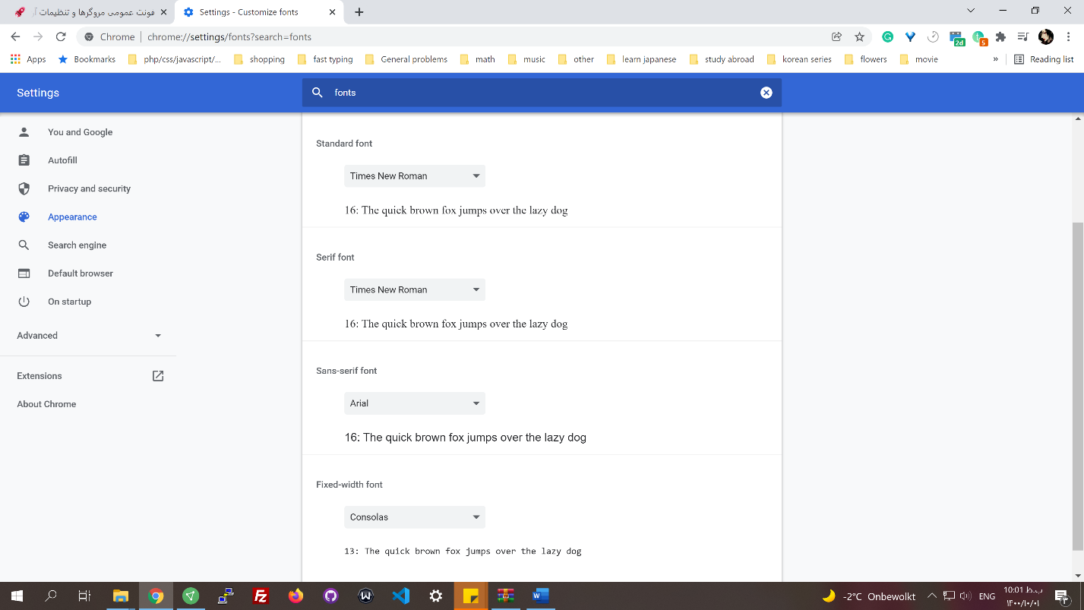

* add font-families to projects // There are some methods that you can achieve this:
* CDN // Persian CDNs: cdn. font-store.ir

<link href="address/font-face.css" rel="stylesheet" type="text/css" />D

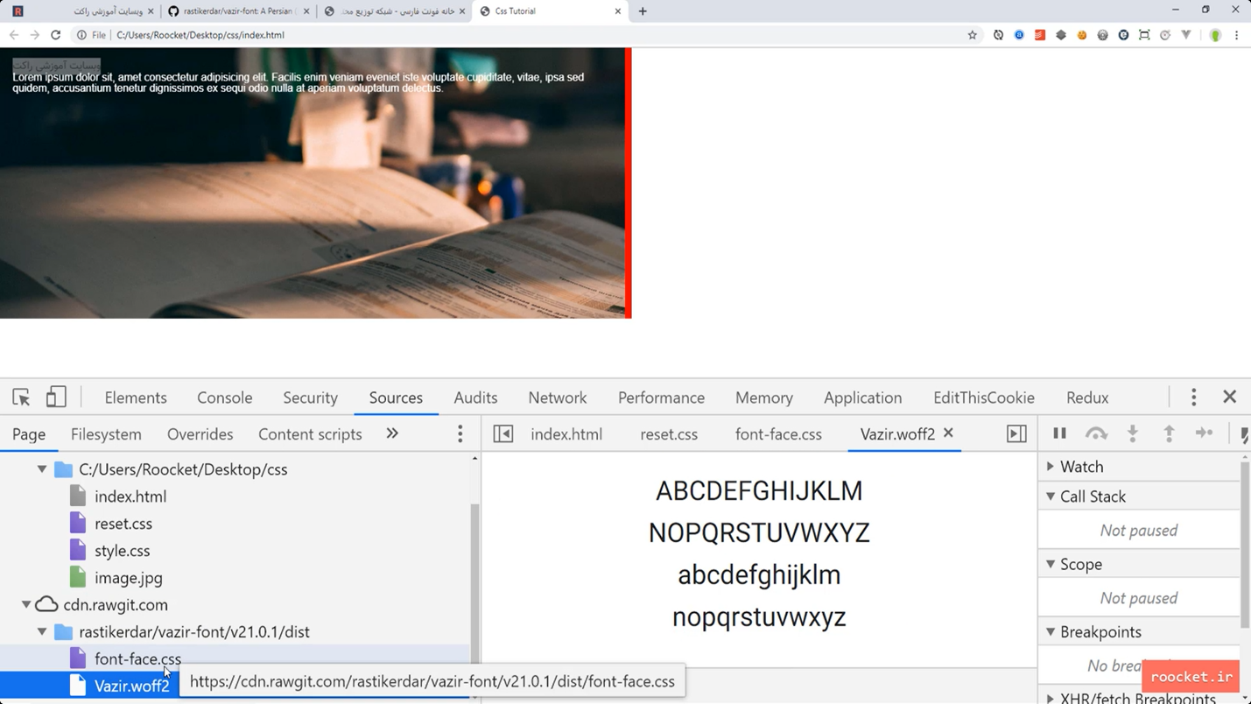

* Font face and fonts in our project

## Web font formats

* **eot** // embedded-opentype. It was introduced by Microsoft and is supported only in internet explorer.
* **ttf** // TrueType. It was introduced by Apple in the late 80s to be used in postscripts. Because of the size, it's not desirable anymore.
* **woff** // it was introduced by Mozilla in about 2009 for web development, and The World Wide Web Consortium accepted it.
* **woff2** // it is woff generation 2. It is compressed better and loads faster compared to woff.
* 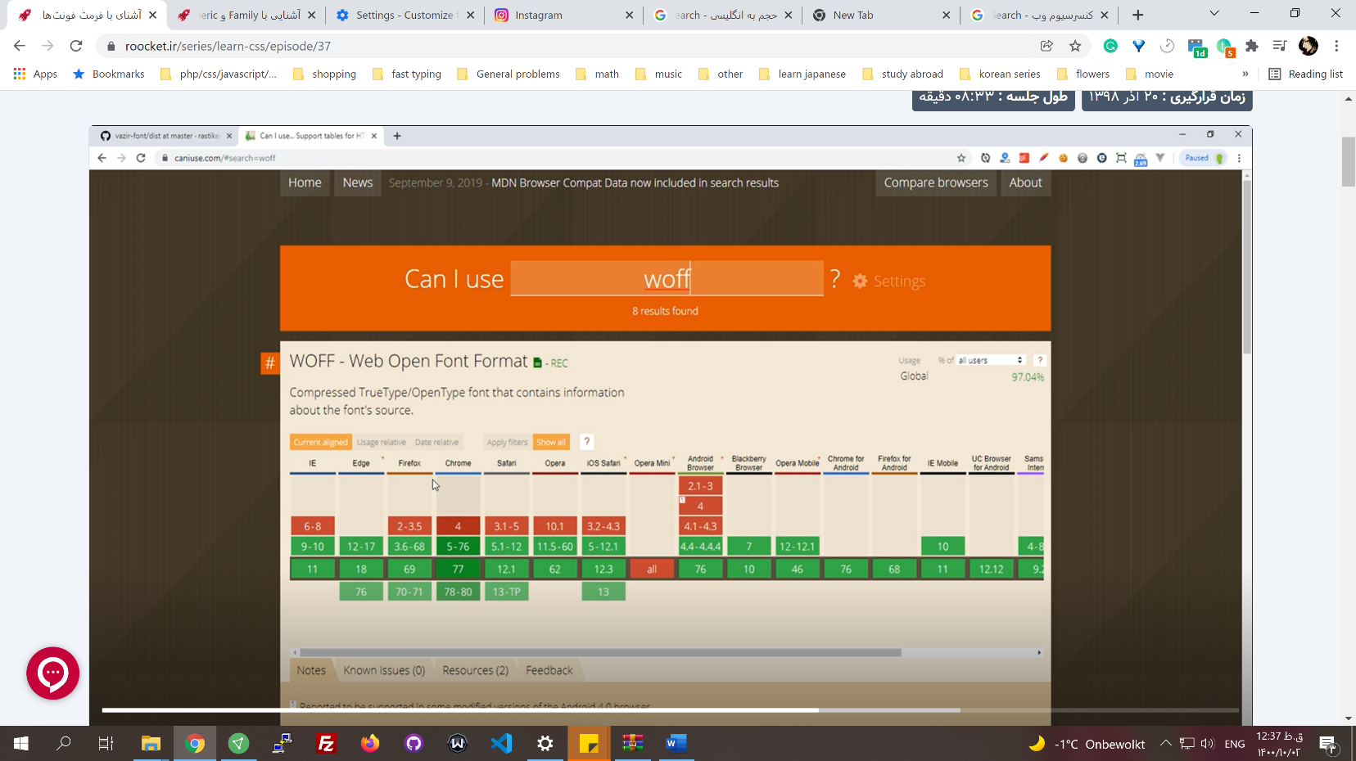SVG fonts

## Define font family

* Download font files
* Since woff is lighter, we should call it first.
* **@** // personalized rules
* **@font-face { }**

@font-face{

Font-family: "Vazir";

src:url(./fonts/Vazir.woff2) format("woff2") // like image sources, format is optional, if you use other format like woff format can recognized it

}

* We can set multiple formats:

@font-face{

Font-family: "Vazir";

src: url(./fonts/Vazir-bold.eot) // cant write a src with multiple url, so use this. IE reads only this, because the rest is not supported and it ignores them.

src: url(./fonts/Vazir-bold.eot) format("embedded-opentype"), // since eot is only supported in IE it can come first

url(./fonts/Vazir-bold.woff) format("woff"),

url(./fonts/Vazir-bold.woff2) format("woff"),

url(./fonts/Vazir-bold.ttf) format("truetype");

font-weight: bold; // this creates Vazir bold, when using font-weight

}

* You can use compressing on the server side to reduce font size even more.
* To use the thinner version, add another @font-face:

@font-face{

Font-family: "Vazir-thin";

src: url(./fonts/Vazir-thin.eot)

src: url(./fonts/Vazir-thin.eot) format("embedded-opentype"),

url(./fonts/Vazir-thin.woff) format("woff"),

url(./fonts/Vazir-thin.woff2) format("woff"),

url(./fonts/Vazir-thin.ttf) format("truetype");

font-wight: 300; // 100 is for thin

}

## Font properties:

* **font-size: 40px;** // it's better to not use px
* **font-wight: 900;**
* **font-style: italic;**
* **font-variant:**
* **font-stretch:**
* **line-height:** **1.8** // between line spaces. In Farsi use between 1.8 – 2. Don't use pixel, use نسبت
* **text-decoration: underline dotted color** // line-through, overline. It's a short-hand
* **text-shadow: offseX offsetY opacity color**
* **text-align: center** // right, left, justify
* **white-space: nor wrap** //break-space, pre . nowrap doesn’t break the lines based on the container's size.

white-space: pre // if you have a enter in html, with this option only those enters are effected on the text.

white-space: pre-line // everything will be wrapped and the enter in html goes to next line

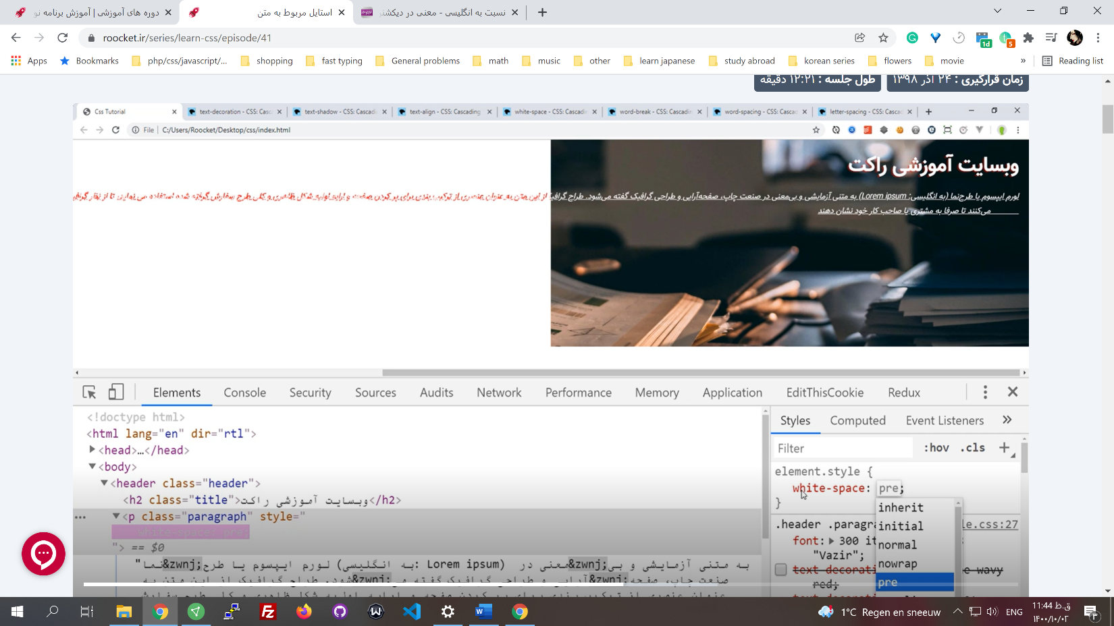

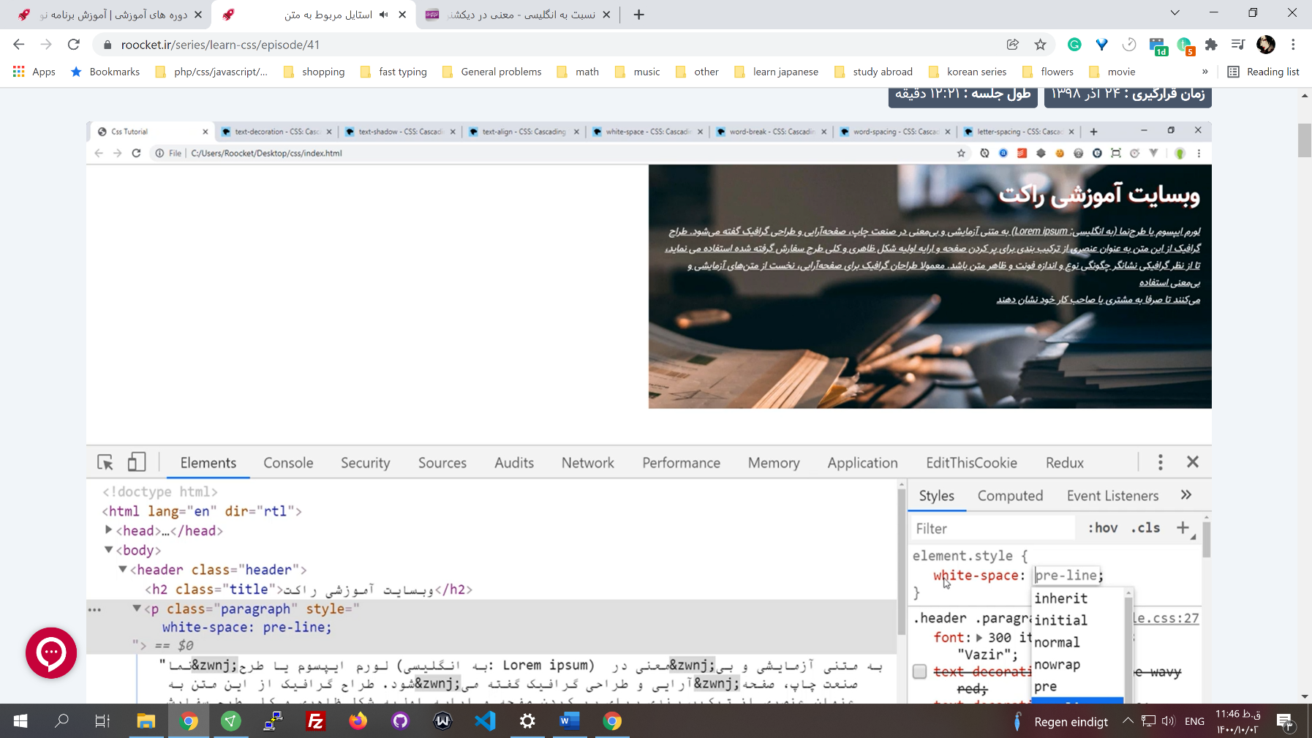

* **word-spacing: 23px** // space between lines
* **letter-spacing: 20px** // space between letters
* **word-break: break-all;** // you have one long word with no space, this will break it. When others are writing a text (reviews, for example), use this

## Font Short-hand

* **font: 20px "Vazir"** // these two values are mandatory, others optional
* **font: 300 italic 16px/1.8 "Vazir";** // size/line-height

Length units

[Values_and_units](https://developer.mozilla.org/en-US/docs/Learn/CSS/Building_blocks/Values_and_units)

* Lamp monitors in the past didn't have many different sizes, so there was no need for different font units. Pixel sufficed. But with LCDs and LEDs and different sizes, and mobile phones, there was the need for responsive sizes.

## Units

* **Absolute** // pt, px, cm. Not good for responsiveness.
* **Relative** // em, rem, vw, vh, %.

## Absolute Units

* How many pixels a 15-inch screen has? Every inch is 96 pixels.

15 * 96 = 1440

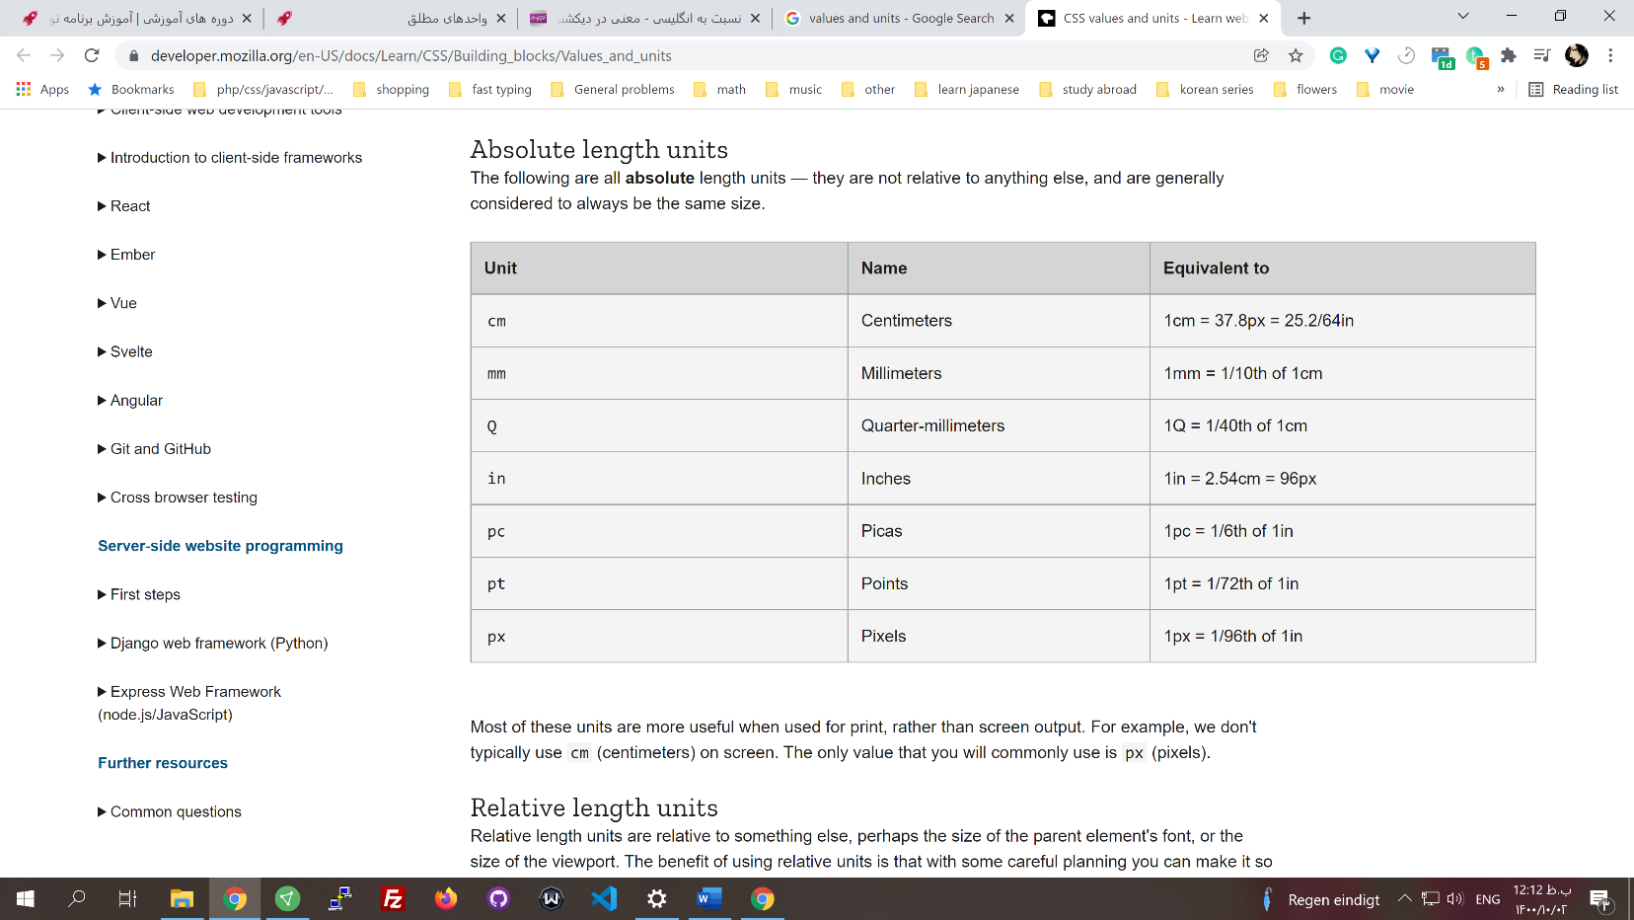

* In absolute units, no matter the screen size, it will show you the exact pixels set for a shape, and to do so, it uses scrolls.

## Relative Units

**%**

* Percentage, in relative to the parent, always

**em**

* em // relative to the font size of the **parent** element. If the direct parent didn't have a font size, it'd check the ancestor tree, and if it reached the HTML and HTML didn't have any font size, it'd take it to form browser settings.

font-size: 16px // parent

font-size: 1em //child 1*16

font-size: 2em // child 2*16

* + The advantage of using em is that if we want to make the font size bigger on smaller screens, we can simply change the parent
  + Another advantage is that you can set the HTML font:100% (it uses browser setting), and by using em, if the user changes the browser font size, it will be affected accordingly in your website.
* rem // rem directly checks the HTML (**root element**) **font size**
* rem and em can be used for other sizings. It is based on the parent **font size**; If none of the parents or the HTML don't have a font-size it takes it from the browser. But it's better to not use the em rem for margin, height, and padding because it becomes unstable and complicated. If you change the font size, all of them will change accordingly and may arise unexpected issues.

**Vw and vh**

* vw (viewport's width), vh (viewport's height) // based on screen size. Be careful when you want to use this.

width: 1vw // 1 percent of the screen size

height: 100vh // 100% of the height of the screen

## Where to use which units?

**Font size**

* **Html tag** // In root element, don't use px; use the browser settings with percent
* **Elements in body** // for **parent** elements use **rem** and for the **children,** use **em**

**Model box**

* **Margin and padding: rem** // It is recommended to use rem. Automatically, sizes change if the user changes the browser settings.
* **Border:** **px** // Because if the font size changes, for example, becomes bigger, the border would look much bigger than desired.
* **Width and height: %** // to be relative to the parent. You can use vw and vh based on specific needs.
* **Top, bottom, left, right: %**

Element position

* Layout // is the design of our theme

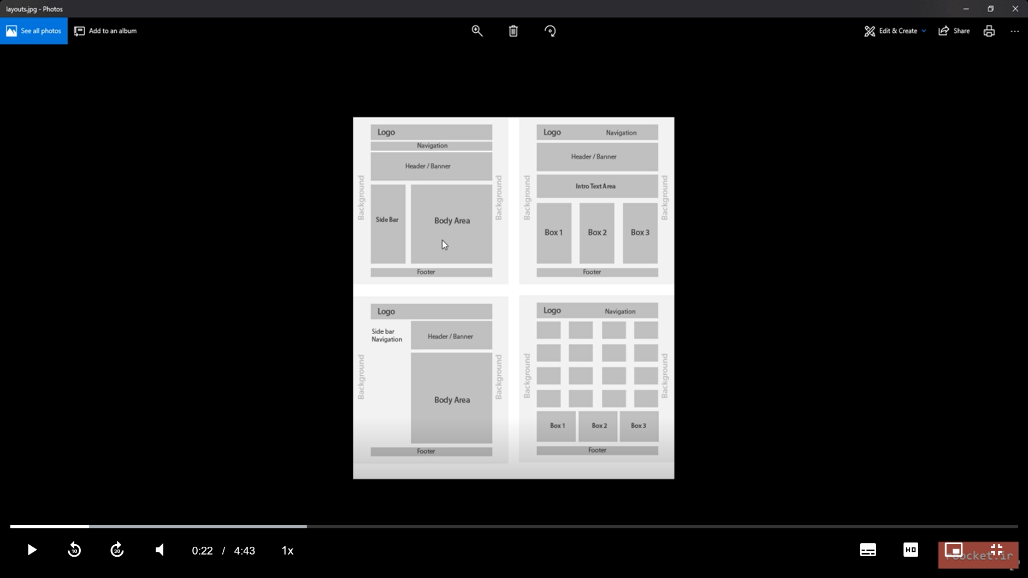

## Display property

* Defines the type of box model appearance
* Span and div // the **difference** are in the **default display property** which is inline and block.

**Inline**

* you **can't** set the **width** and **height** for inline elements. The width and height are relative to its content. Another characteristic of inline is that elements with this kind of display **only push each other from the right and left.**

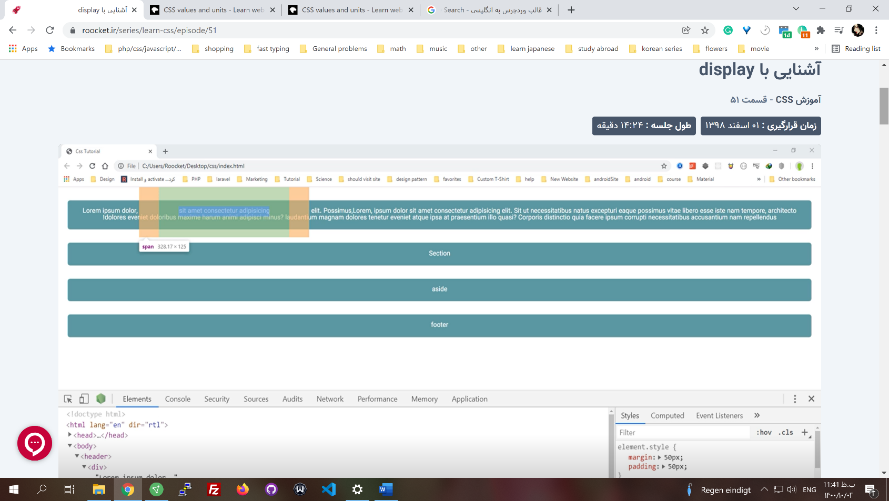

Two spans <span><span></span></span>

* Elements that have default inline display:
  + **Span**
  + **em**
  + **img**
  + **strong**
  + **input**
  + **label**

**block**

* 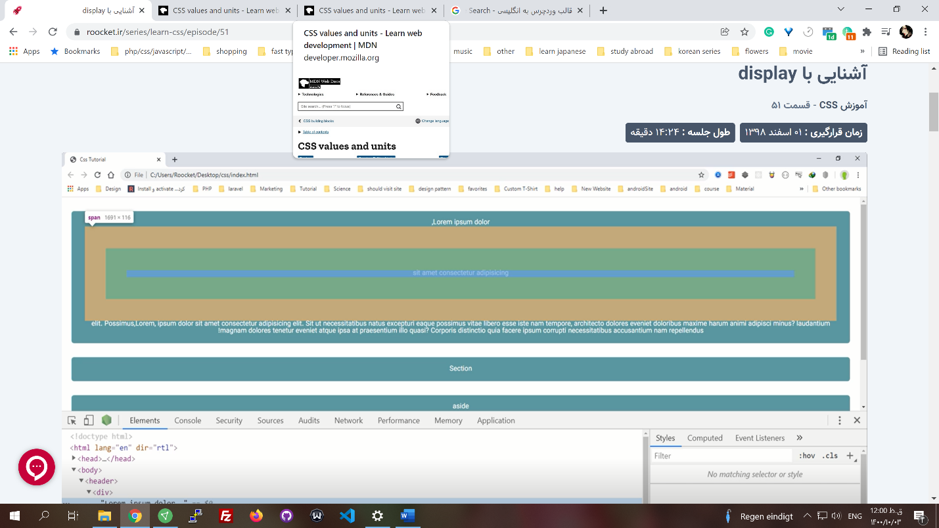 It starts on a new line, and takes up the whole width. It has a separate line space. **A full separate block**.

**Inline-block**

* Similar to inline, it gets width and height, and the margins and paddings are affected from all directions. It **doesn't take a full separate block** (section).

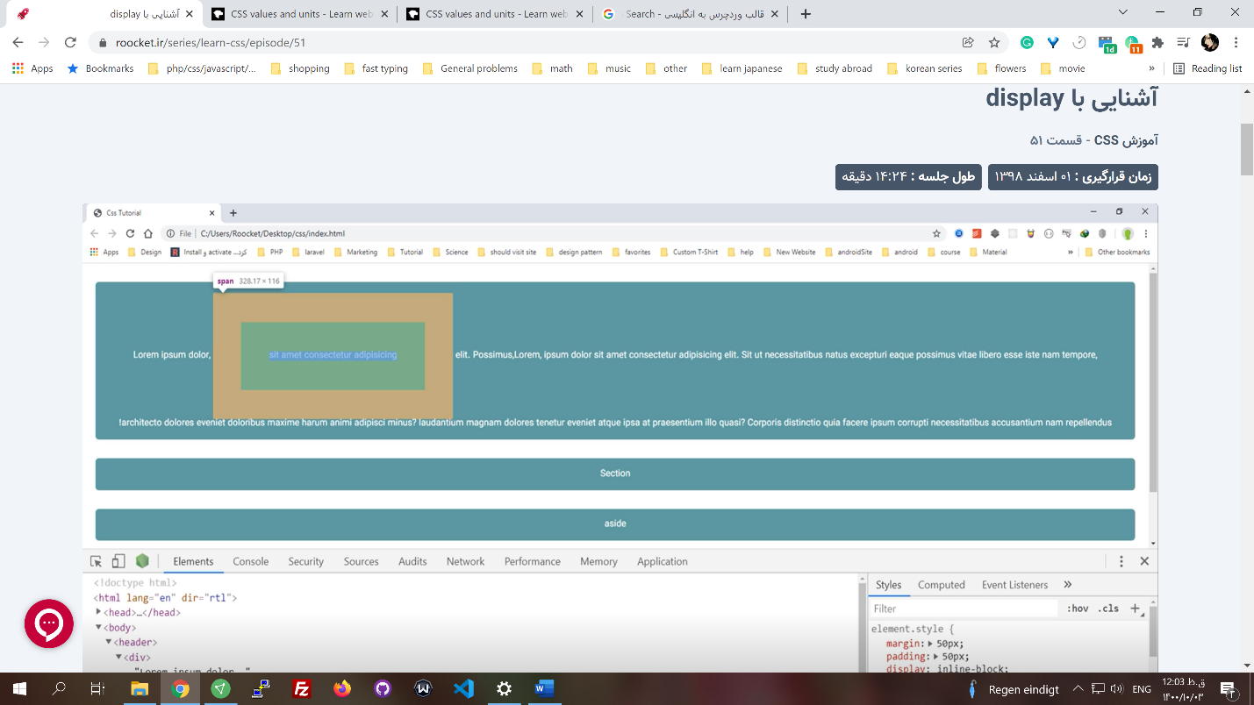

**Item-list**

* To act like lists. Inherit list characteristics.

**Table**

* To act like tables

## Float

* It's not used anymore since it can create bugs. It may be used in very specific places where nothing else works.
* float: right
* float: left
* clear: both
* if the children in a div parent have float left or right, the parent height doesn't expand to the children's. If you don't want to use clear: both on the next element of the float ones, the one that is not part of the float, use clearfix on the parent.

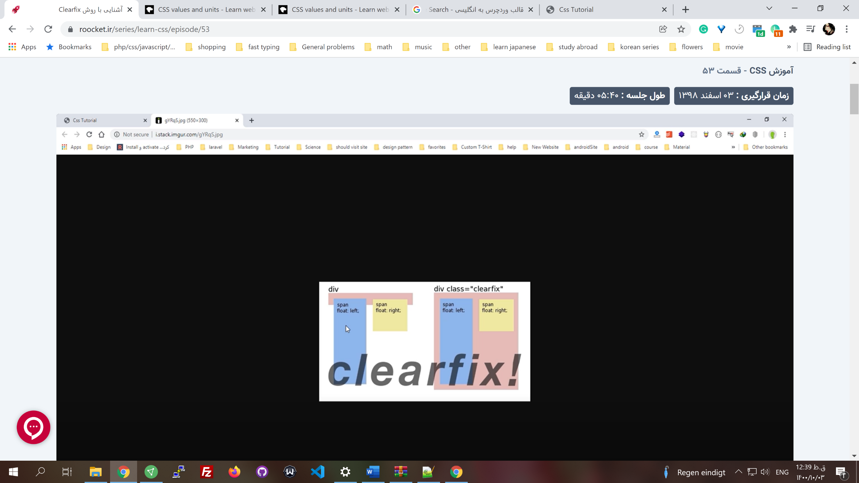

item{

float: right

}

.clearfix:before, // parent of item

.clearfix:after{

content: "";

display: table;

}

.clearfix:after{

clear: both

}

* When you have a row of elements with a percentage width that each has a margin, it includes those margins in width calculations. Margin pushes the last element down because it is included in the sum of all the widths. To solve this issue, you can use calc()

margin: .5rem;

width: calc(33.33% - 1rem) // three elements in a row minus the margin from left and right

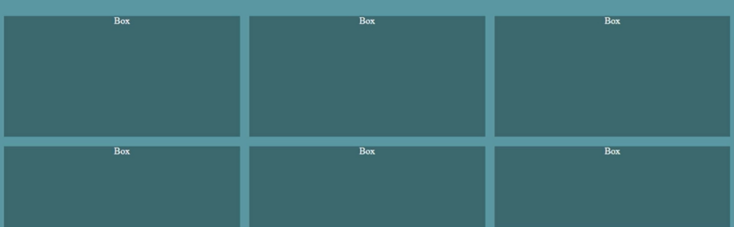

## Inline-block: Alternative to float

* **display: in****line-block** includes the spaces and \n between HTML tags in the HTML file to align the item. To solve this issue, we don’t use space or \n between tags. This is what most programmers do.

[remove-the-space-between-inline-block-elements](https://stackoverflow.com/questions/5078239/how-do-i-remove-the-space-between-inline-inline-block-elements)

<ul>

<li>Item 1</li>

<li>Item 2</li>

<li>Item 3</li>

</ul>

********

<ul>

<li>Item 1</li><li>Item 2</li><li>Item 3</li>

</ul>

*******

<ul>

<li>Item 1</li><!--

--><li>Item 2</li>><!--

--><li>Item 3</li>

</ul>

## Reusable layout

* Use predefined classes.
* Divide the screen into a specific number of columns.

.col-1 {

width: 33.3333333333333%;

}

.col-2 {

width: 66.6666666666667%;

}

.col-3 {

width: 100%;

}

.col-1, .col-2, .col-3 {

display: inline-block;

vertical-align: top;

}

.col-1, .col-2, .col-3 {

padding-right: 15px;

padding-left: 15px;

}

## Positions property

* **position: static** // default
* **position: relative** // you can set left, right, top and bottom
* position: absolute // you can set left, right, top, and bottom, check the parent line which one has relative. If no parent is relative, take the body as the model box.
* **position: fixed** // fixed on the screen
* **position: sticky** // The element will scroll along with its container until it is at the top of the container (or reaches the offset specified on top), and will then stop scrolling, so it stays visible.

position: -webkit-sticky;

position: sticky;

top: 20px;

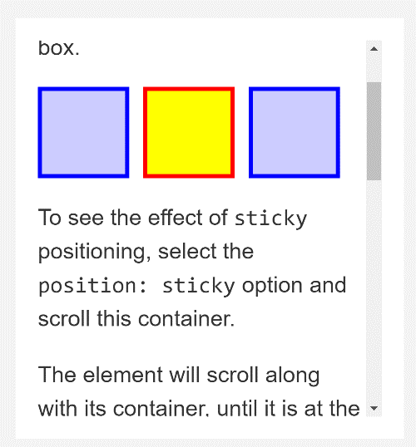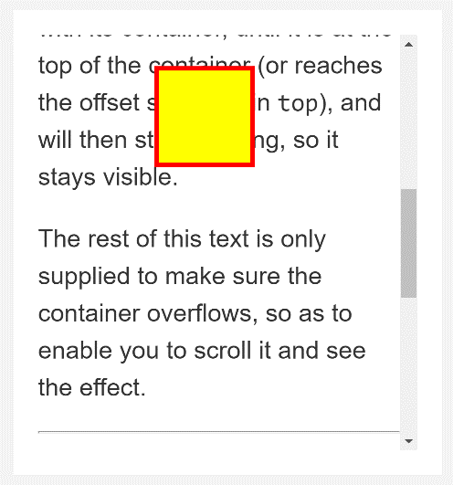

20px

* The difference between relative and absolute is how the element has a position compared to other elements. In absolute, the default position ( How the element is placed in the screen) is ignored. It takes no space in the normal flow of the page. In contrast, the relative keeps that space.

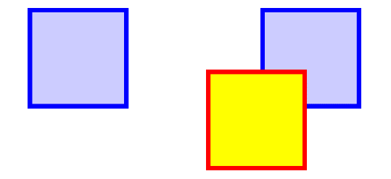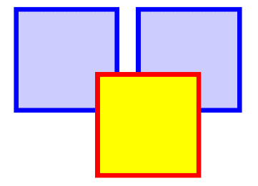

absolute

Top:

Right:

relative

Forms

## inputs

* **Input[type=""]**
* **Input:not([type=""])**
* **Input:focus{}**
* **font-family: inherit**
* **padding: .6rem** // use paddings instead of heights
* **border-radius: 4px** // you have to reset the border if you want to have a nice radius
* **input::placeholder{ color: red }** // pseudo-element, from 51 firefoxes is supported in this way

.form input.form-control::placeholder, //Firefox 51-last

.form input.form-control::-moz-placeholder, // Firefox 19-51 ::

.form input.form-control:-moz-placeholder, // Firefox less than 19 :

.form input.form-control::-webkit-input-placeholder, // chrome 6-57

.form input.form-control::-ms-input-placeholder { // for IE 10 and 12

color: red;

}

**Checkbox**

* **font-family: inherit**
* **padding: .6rem** // use paddings instead of heights

<lable for="rules" class="checkbox">

<input type=""checkbox" name="rules" id="rules"> I agree

<span class="checkmark"></sapan> //tick

</label>

.checkbox input{

display: none;

}

.checkbox .checkmark{ //not checked

display: inline-block;

background-color: #eee;

height: 25px;

width: 25px;

}

.checkbox input:checked ~ .checkmark{ // a label that comes after input:checked

background-color: #2196f3;

}

checkmark: after{

content: "";

position: absolute;

display: none;

width: 5px;

height: 100px

border: solid white;

top: 5px;

right: 8px;

border-width: 0 3px 0 3px // top right bottom left

transform: rotate(45deg);

}

.checkbox input:checked ~ .checkmark:after{ // a label that comes after input:checked

display: block;

}

**Focus**

* **:focus** // pseudo-class
  + click on input:

input:focus{

background: #ddf1f2;

outline: none;

border: 1px solid #607f81!important

}

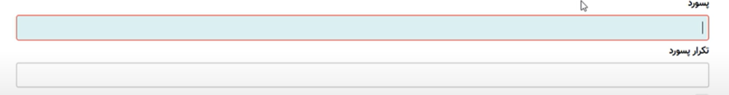

**Validating**

* Server and frontend
* **:invalid** // Pseudo class. It is not used much because it can be easily **bypassed**. It works with **password min length**, **required HTML attribute**, **input type email**, and **form tag**.

input:invalid{

border: 1px red;

}

**button**

* We should directly assign a **font family**, the font family on the parent is not affected on the buttons.

.btn-danger {

background-color: #e74c3c;

color: white;

border: 1px solid #933026;

}

**Responsive**

[**mydevice.io/**](https://www.mydevice.io/)// shows the device screen size

* viewport meta tag [Viewport_meta_tag](https://developer.mozilla.org/en-US/docs/Web/HTML/Viewport_meta_tag) // to make our website responsive **you should add this tag**. If you don't have a meta tag, grid for example doesn't work on chrome.

<meta name="viewport" content="width=400 initial-scale=1.0 user-scalable=yes, maximum-scale=3.0, minimum-scale=2.0">

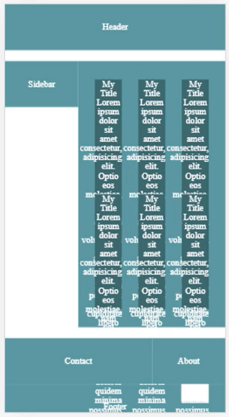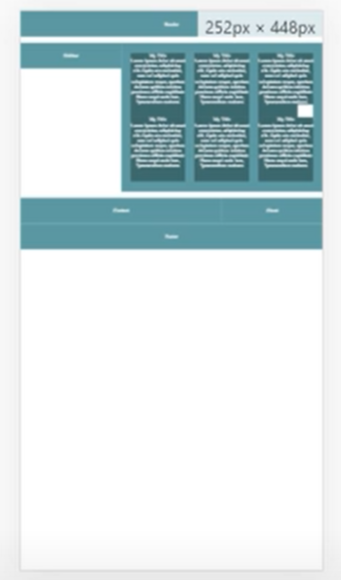

With view port

Without view port

* **width: device-width** // if we set the viewport width=400 like above, it will keep that width on responsive mode
* **initial-scale = 1.0** // is like zoom. 1.0 is the default, 3.0 for example, is three times the normal size. Like how you zoom in on mobile phones.
* **user-scalable=yes** // if set to no, the user can not zoom on mobile devices.
* **maximum-scale=2.0** // if zoom is possible this is the maximum scale possible
* min-width and max-width properties in CSS are very useful in writing responsive pages.

@media query

* It helps to give different styles for an element on different screen sizes. See [Using_media_queries](https://developer.mozilla.org/en-US/docs/Web/CSS/Media_Queries/Using_media_queries).

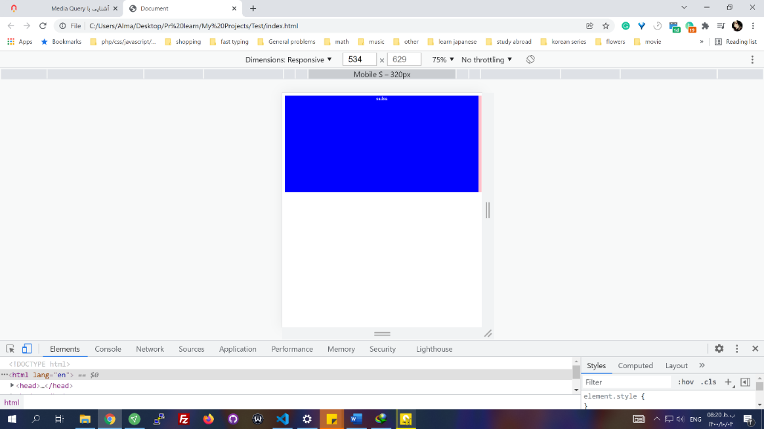

Mobile s = mobile small

New smart phones are usually bigger or equal to 320px

These sizes shown here are called **break points**



* We can have as many media queries anywhere we want
* **@media(width:768px){ }** //is effected only on 768px
* **@media(min-width: 768px){}** // is effected for screens with at least width: 768px
* **@media(max-width: 767px){}** //

**Three parts for media queries**

* Media types :
  + **all** //if not given default is all
  + **print** // print is used when you want to print from a text in a webpage (ctrl + p). With CSS and media queries, we can set a style for printed layout.
  + **Screen** // for all devices with screens: smartphones, laptops, tablets, desktop LCDs, ….

@media screen, print { … }

* + **speech** //some tools can read (in sounds) different parts of a webpage
* Media features:
  + max-width
  + min-width
  + width
  + orientation (landscape or portrait).

@media **(**hover: hover**)** { ... } // **features should be inside parenthesis**

@media (color) { ... }

@media speech and (aspect-ratio: 11/5) { ... } // for speech tools and an option is activated(aspect-ratio: 11/5) for this tools

* Logical operators: and, not, only, comma

@media screen **and** (min-width: 30em) **and** (orientation: landscape) { ... }

* Don't use pixels
* Order of media queries is important

## Mobile-first

* First, make your layout for your mobile
* Write your CSS for mobile Use **media queries** with **min-width for bigger screens**

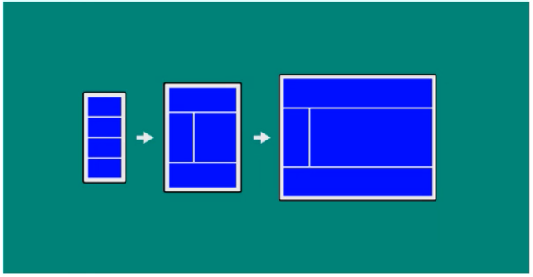

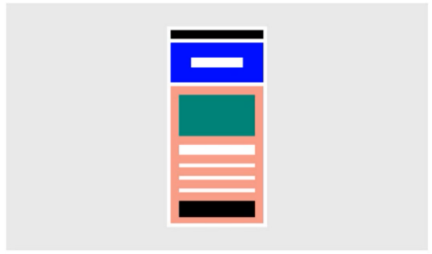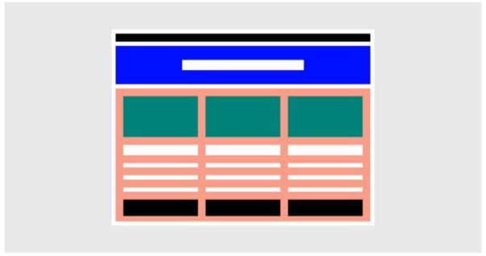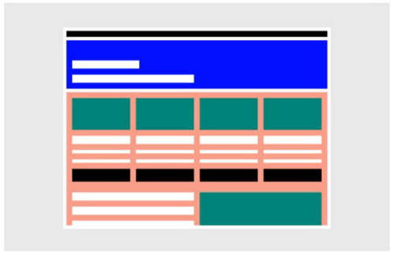

Mobile

Tablet

Laptop

## Standard Sizes:

* 320px — **480px**: Mobile devices
* 481px — **768px**: iPads, Tablets
* 769px — **1024px**: Small screens, laptops
* 1025px — **1200px**: Desktops, large screens
* 1201px and more —  Extra large screens, TV

Transforms

[**CSS_Transforms**](https://developer.mozilla.org/en-US/docs/Web/CSS/CSS_Transforms)

* CSS Transforms is a module of CSS that defines how elements styled with CSS can be transformed in two-dimensional or three-dimensional space.
* **Transform: scale(2)** // All the content will be scaled. The element given this style keeps its initial width and height values as computed ones. Only what is shown is two times the initial.
* **Functions:** // can be used together transform: scale(1.5) rotate(45deg) translate(30%,50%) ;
  + **Matrix(1,2,3,4)**
  + **Translate(120px, 50%)**
  + **Scale(2, 0.5)**
  + **Rotate(0.5trun)**
  + **Skew(30deg, 20deg)**
  + **Scale(0.5) translate(-100%, -100%)**
* **Note*:** *If you want to apply multiple transformations to an element, be careful about the order in which you specify your transformations. For example, if you rotate before translating, the translation will be along the* ***new axis*** *of* ***rotation****!*

## Rotate

* rotate = rotateZ, rotateX, rotateY
* rotate (numdeg)



RotateZ



RotateY

RotateX

## Transform-origin

* **Transform-origin:** **x, y, z offset** // default is center [transform-origin](https://developer.mozilla.org/en-US/docs/Web/CSS/transform-origin)

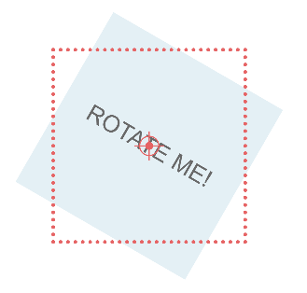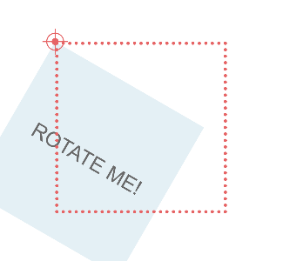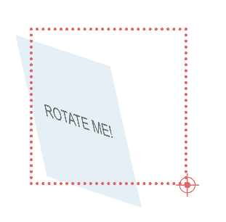

Transform-origin: center

Transform-origin: top left

Transform-origin: bottom right 60px

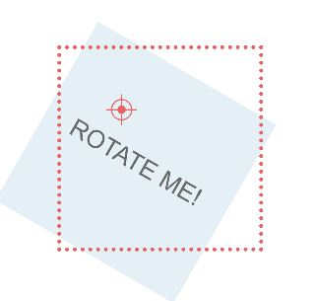

Transform-origin: 50px 50px

Fixed point



## Skew (مورب)

* **­­­Transforms: skew(x,y), skewX(), skewY()** // The effect is as if you grabbed each corner of the element and pulled them along a certain angle. **It'll change the axis of x and y for the element**.

Transform: skewY(30deg)



skewX



skewY

* **Note:** *Skew changes the x and y-axis. It'll affect other transforms used with this function.*

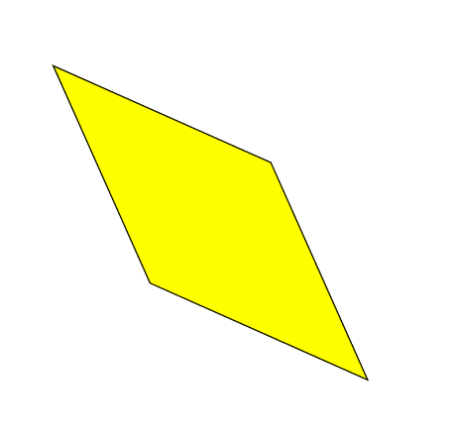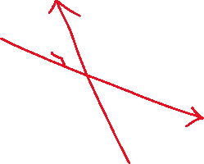

skew(x,y)

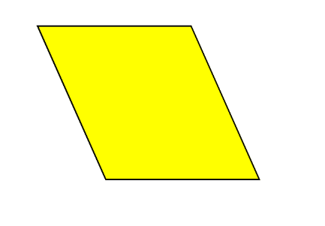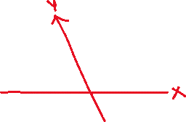

Skew(x)

## Translate

* **translate(x,y), translateX, translateY, translateZ(in 3d space)**

## 3d

* **perspective** // to see elements as 3d objects, we have to change our perspective

transform = perspective(10px) rotate(4deg)

* Perspective(0): we see one line. Imagine the element is a square wall; in perspective 0, we are looking at the wall from one side.

Look from here

You see this

If you set a good perspective and rotate(90deg).

In css elements don't have thickness, so you don't see anything.

Set a border to see it

* The higher number in perspective means you are looking at it from a distant
* When creating an element with different sides, like a cube, it's better to give the perspective of a parent element having all sides.
* **Perspective:1000px**; // it should be **used on the parent**, **on children with transform won't work**; you should use perspective with transform to work together on **an** element which means children of that element with perspective:1000px will be affected.

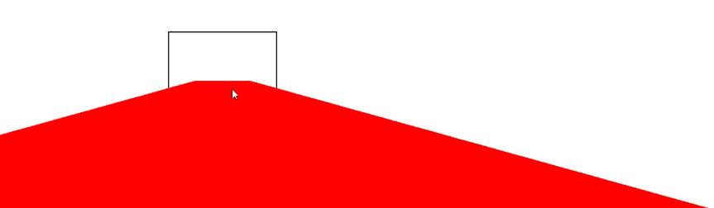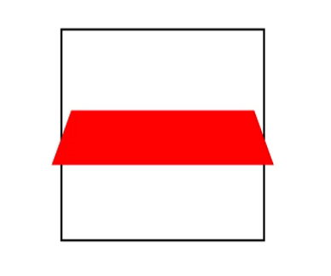

Child red: transform: rotate(75deg)

Parent black border: Perspective:1000px;

Parent black border: Perspective:100px;

* **perspective-origin: center, right, bottom, left, top**

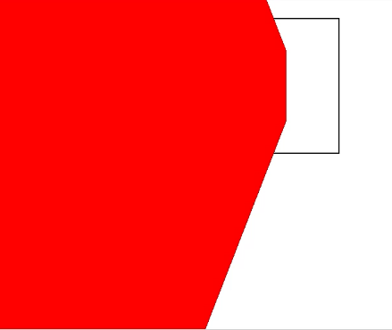

perspective-origin:center // default

perspective-origin:bottom

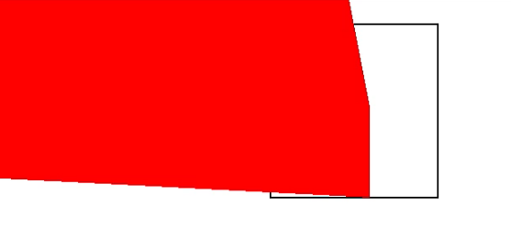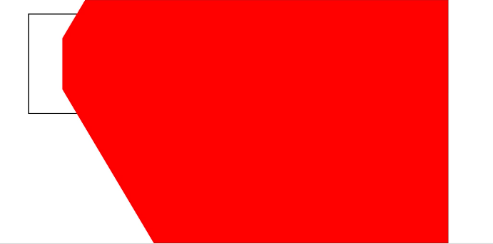

perspective-origin:left

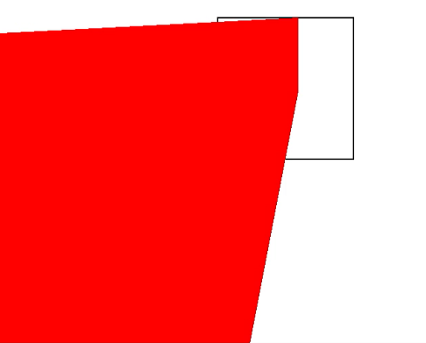

perspective-origin:top

## 3d cube

* **perspective: 600px** to a parent element that has all sides.
* **perspective:1000px;** // it should be used on the parent; on children with transform won't work; you should use perspective with transform to work together on **an** element. While with this method, the children of that element with perspective:1000px will be affected.
* To have a correct perspective, we should **give the same parent the same height and width as faces**.
* **transform-style: 3d** // **flat** is the **default value**. To transform all the faces at once, we set **another parent** (aside from the perspective on great parent) **with transform: rotate(35deg)**; only this makes all the faces collapse and become one.

<div class="scene">

<div class="cube">

<div class="cube__face cube__face--front">front</div>

<div class="cube__face cube__face--back">back</div>

<div class="cube__face cube__face--right">right</div>

<div class="cube__face cube__face--left">left</div>

<div class="cube__face cube__face--top">top</div>

<div class="cube__face cube__face--bottom">bottom</div>

</div>

</div>

* **transform-style: preserve-3d** // To **preserve** the children's transforms, we use this property. Also, **this helps with absolute positioning**, so we don't need a z-index attribute or change the order of the elements. If the rotation moves the whole cube, you have to set a height and width for this parent.

.scene {

width: 200px;

height: 200px;

perspective: 600px;}

.cube {

width: 100%;

height: 100%;

position: relative;

transform-style: **preserve-3d**;}

.cube__face {

position: absolute;

width: 200px;

height: 200px;}

.cube__face--front { transform: rotateY( 0deg) translateZ(100px); }

.cube__face--right { transform: rotateY( 90deg) translateZ(100px); }

.cube__face--back { transform: rotateY(180deg) translateZ(100px); }

.cube__face--left { transform: rotateY(-90deg) translateZ(100px); }

.cube__face--top { transform: rotateX( 90deg) translateZ(100px); }

.cube__face--bottom { transform: rotateX(-90deg) translateZ(100px); }

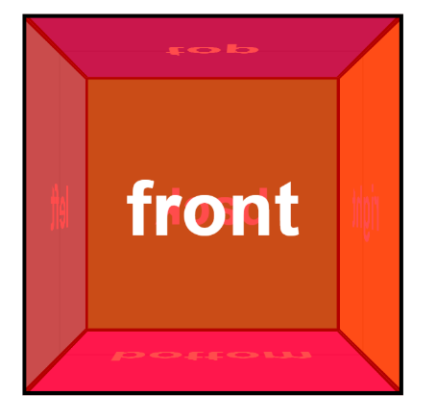

Transition

* To change style through a period of time
* **transition-property: transform, border;**
* **transition-duration: 500ms, 4s ;** // 4s is for border above
* **transition-timing-function: ease-in, ease-out, ease-in-out**
* **transition-delay: 1s**
* **transition : transform 2s ease-in, border 4s ease-out;** // shorthand
* **transform:** all 2s; // all on all properties

## Transition-timing-function

* [easings](https://easings.net/)
* **cubic-bezier()** // timing

animations

* @keyframes // it is made out of some keyframes (

@keyframes rundCube {

from{

transform: rotateY(0) scale(1)

}

to{

transform: rotate(220deg) scale(1.4)

}

}

*  animation: runCube 3s ease-in 2s 3 alternate;
* **transition-count: infinite** // if you want to use **alternate** this should be set to 2 for example
* **direction: alternate** // from-to and then to-from
* **direction: alternate-reverse** // to-from then from-to

## keyframes

* 0%, 10 %, … // each one is a keyframe, a step based on total animation time

@keyframes runCube {

0% {

transform: rotateY(0) scale(1);

}

20% {

border: 10px solid black;

transform: rotateY(-100deg) scale(.7);

}

80% {

border: 20px solid red;

transform: rotateY(270deg) scale(1.6) ;

}

100% {

border: 5px solid yellow;

transform: rotateY(220deg) scale(1.4) ;

}

}

FlexBox

* It is a module for creating a dynamic layout. CSS Flexible Box Layout is a CSS 3 web layout model, commonly known as flexbox. It is in the W3C's candidate recommendation stage. The flex layout allows responsive elements within a container to be automatically arranged depending on screen size.
* It was Box in 2009, then in 2011 became flexbox, but World Wide Web Consortium (W3C) changed to flex in 2012. [a-guide-to-flexbox](https://css-tricks.com/snippets/css/a-guide-to-flexbox/)

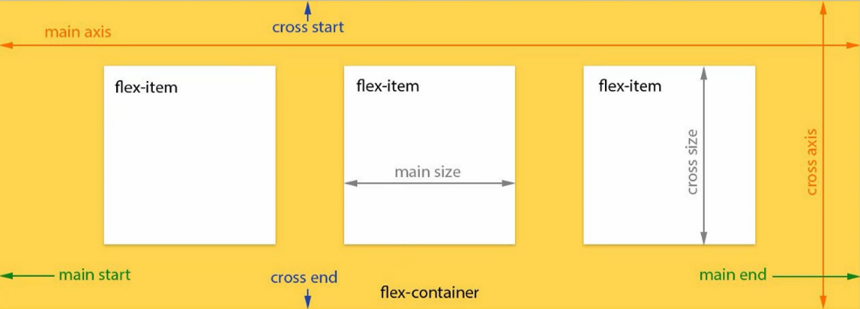

## Container properties

**display: flex**

* the container will be like a block div that covers all widths of the screen

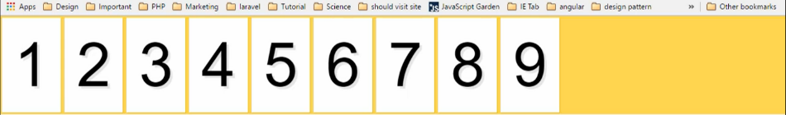

**display: inline-flex**

* similar to above but only covers the children

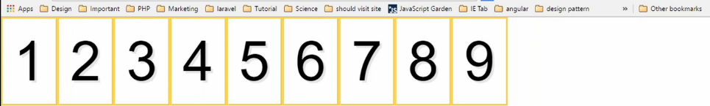

**flex-direction**

* flex-direction: column, row, column-reverse, row-reverse // default is the row

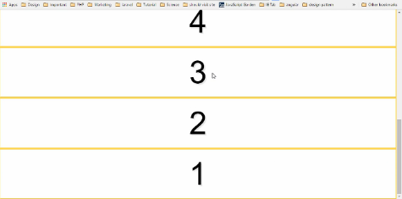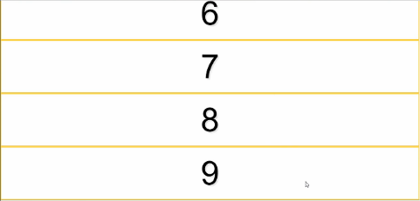

flex-direction: column

flex-direction: column-reverse

**flex-wrap:**

* **nowrap** // default is nowrap. It puts the items in one line. Widths on items are not affected if you set flex-wrap to nowrap.

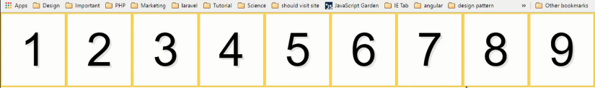

flex-wrap:nowrap

item width: 33.333333

* **wrap**// the widths are affected. And it breaks the items into multiple lines.

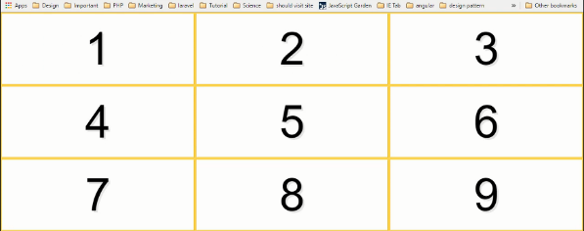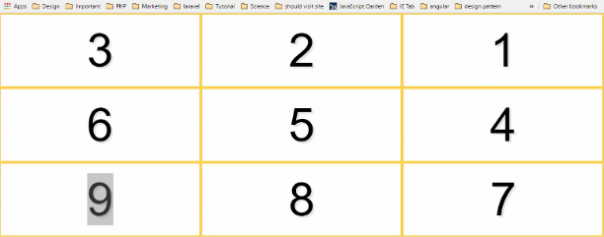

Row-reverse and wrap

* **wrap-reverse**

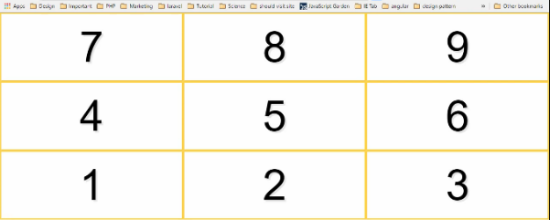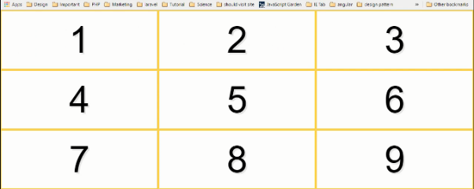

* **flex-flow: flex-direction flex-wrap** // short-hand for flex-wrap and flex-direction

**justify-content:**

* **center**  // works for both flex-direction. center in the line if flex-direction: column and if flex-direction: row it also works on the column direction the justify will be on column direction. This is the column:

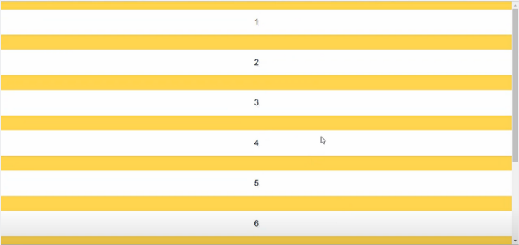

* **flex-end** // brings all the items to the end of the flex container (to the right)
* **flex-start** // brings all the items to the start of the flex container (to the left)
* **space-around** // puts an even space to the left and right of the items

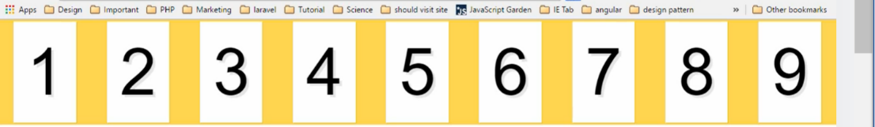

* **space-between** // just between item



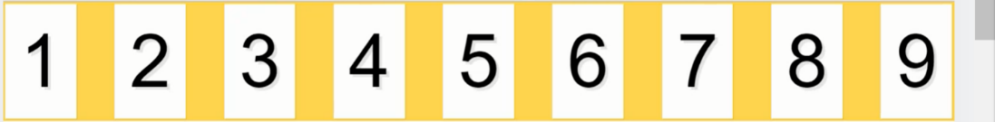

* **space-between** // just between item

**align-items:**

* Items' position in the height (cross-axis) direction of the container. For **direction: column** will be reversed in direction, meaning changes where they are placed in the row.

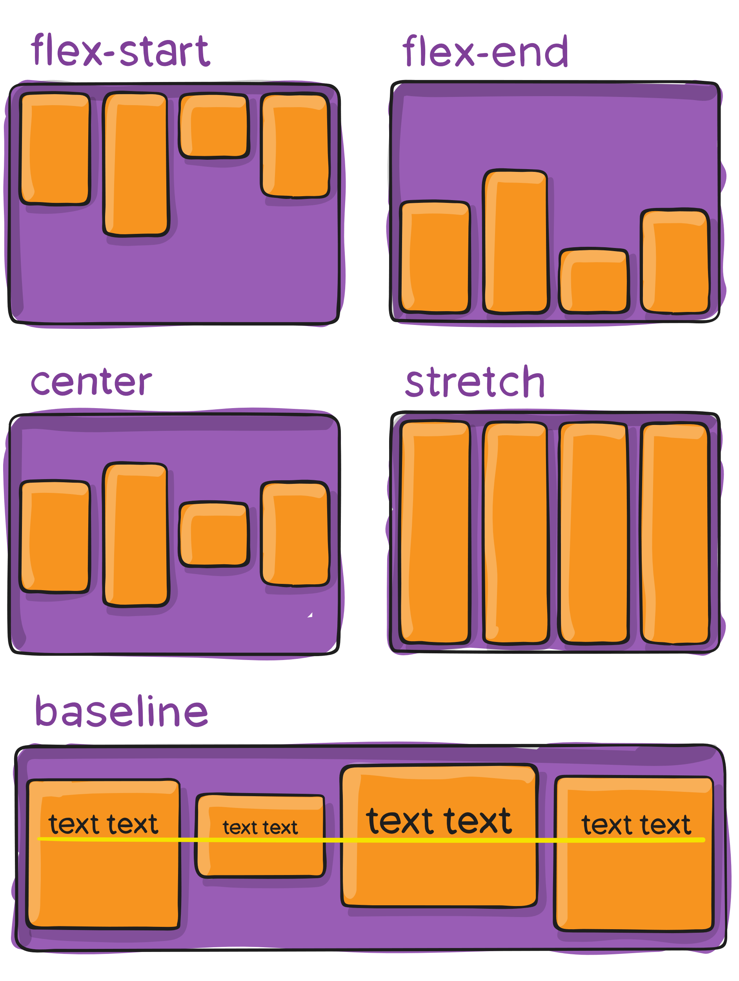

* **center**
* **flex-start** // at the top of the container
* **flex-end**
* **baseline** // items are aligned such as their baselines align
* **stretch //default**

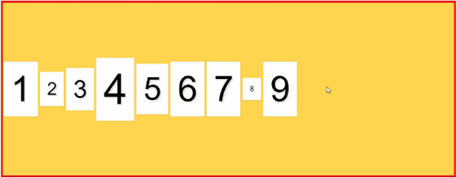

center

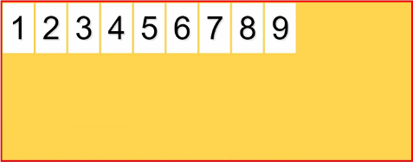

start

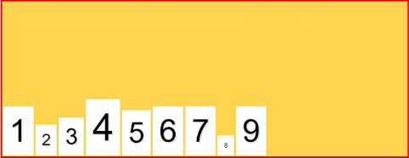

end

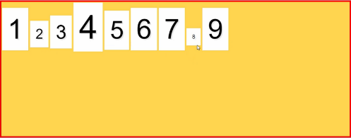

baseline

**align-content**

* the container should have a height and **should not be nowrap** because it puts them in one line, but align-content works on the **cross-axis**.
  + center
  + space-around
  + space-between
  + stretch // default

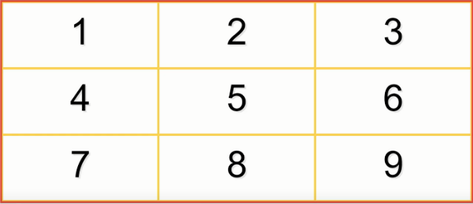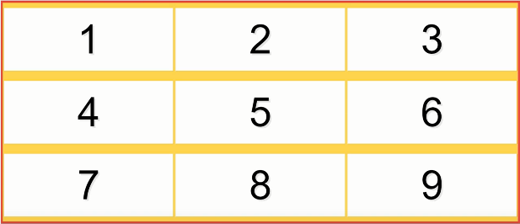

stretch

Space-around

## Flex item properties

* **flex-grow** //default 0. It can be a number (1,2,..). Item given this property grows as much as **covers the empty spaces** in the container. You have nine items, 8 of them have flex-grow 1, and one has 2 => 1 * 8 + 1 * 2 = 10. The empty space will be divided into 10.

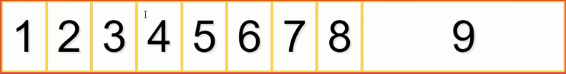

flex: 1, It is given to this item only

Given to all, they grow the same size to cover the empty space

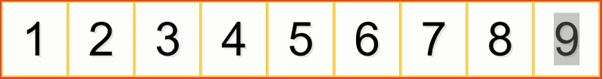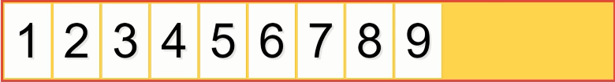

Number 1 has **flex: 2** // the **amount given to fill the space is multiplied to two**

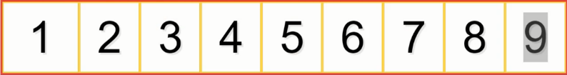

* **flex-shrink** // 1 is the default. That means your elements will shrink until you tell them not to! We can give a value (like 2) which will be how much compared to other items will be shrunk. The item becomes smaller. We should **have** a **flex-basis** for **flex-shrink to work**. Because there should be a base for how shrink happens, when the screen is smaller than the sum of the flex-basis in all items, the item having a shrink higher than one will get smaller x(the value for flex-shrink) times more than the other item. We can **have flex-shrink and flex-grow both** together. **Flex-grow will be affected when there is empty space** in the container and shrink won't work.
  + If there is a **flex-grow value**, the element **won’t shrink smaller than its content**. An element with a flex-shrink value of 1 will shrink, but not smaller than its content.
  + Flex-shrink is about **proportions**. If one box has a flex-shrink of 6, and the rest have a flex-shrink of 2, the one box will shrink 3x as fast as the rest, as space compresses.
* **flex-basis** // a **base width or height** (based on direction) for the items so should have a **unit**. **The width won't be smaller than the given number.** Then you can set the grow so if there is space they can grow in width. If there is a flex-grow on one of the items, flex-grow will be affected if the size of the screen is bigger than the **sum flex-basis for all items**, which means that if there is free space. Don't forget the **wrap** in the flexbox. In scss:

>li{

list-style: none;

padding: 1.2em 0.4em;

@media screen and (min-width: 460px) and (max-width: 766px) {

flex-basis: calc(50% - .8em); // double the 0.4 right left

}

flex-basis: calc(25% - .8em);

flex-grow: 1;

}

* + We have three items that have more than 25% flex-bases since grow is 1. The first pic is for the media screen.

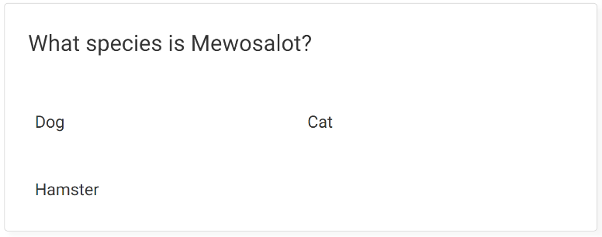

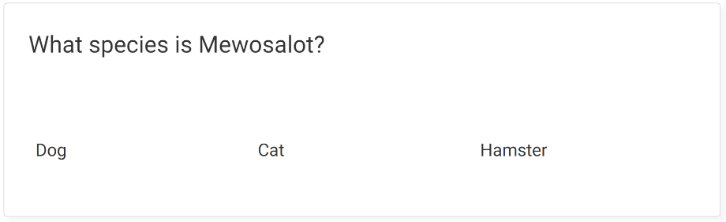

* **flex: grow shrink basis** // shorthand

flex: 0 0 auto; // flex: 0 0 0 won't work

* **order: 0** // default is 0. Positive and negative numbers. If two items have the same order, the order is based on the tag position in Html.

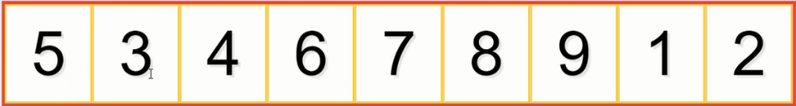

* **align-self** // similar to align-items, but only works on that element. It overwrites the align-item value.

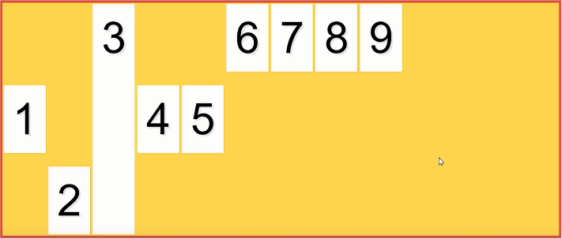

Number 8 has align-self: baseline but since align-items: start, it is positioned based on that

**exercise**

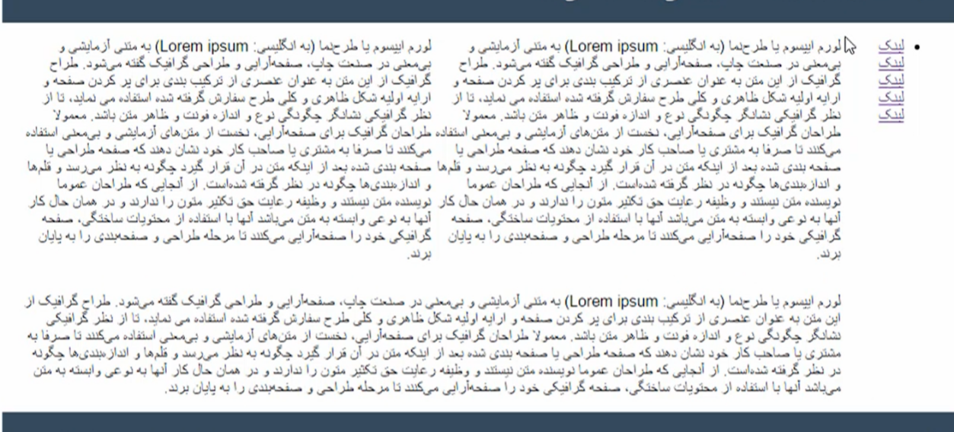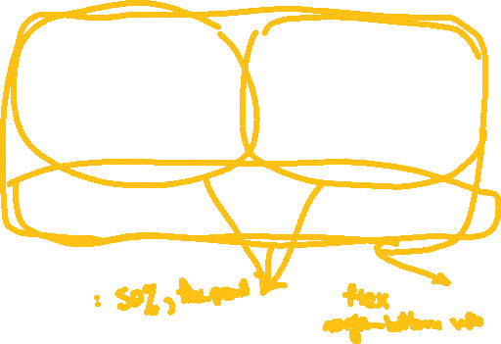

Grid

* we usually can make almost anything wirh flex, but for **dual axes design** grid may be useful.
* **display: grid** // firefox has a built-in tool for gird in the inspector, in the rules and layout tab.
* **grid-template-columns: first column width, second column width, third …** // any number of columns you want

**grid-template-columns: 100px 200px 1fr;**

* + The third column takes up the remaining available space (1fr means one fraction of the available space).
* **grid-template-rows: first row height, second-row height, third …** // auto. the number of actual rows may not be the same as defined here based on what layout you have designed; some elements may need to go to a new row. But with this, you can set the height of rows and have a more visually appealing view in general.
* **Justify-content and align-items**// Place the div in the center of the line

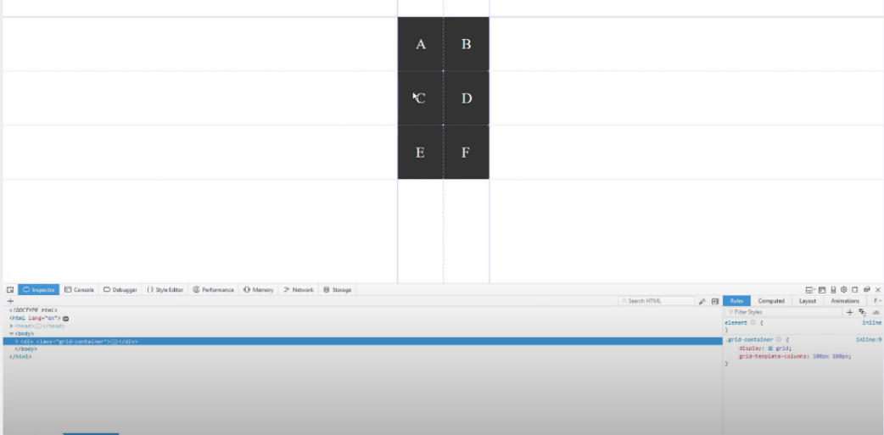

## gap

Space between items, in columns and rows. **Grid-gap now is the gap.**

* column-gap: 3em
* row-gap: 3em // second picture grid-column-gap like above
* gap: 3rem // Short-hand for row-gap and column-gap

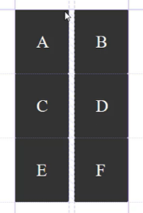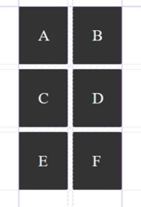

grid-column-gap: 3em

grid-row-gap: 3em

## Item properties

* **grid-column-start: column-number** // A number that tells where the item starts in the grid layout
* **grid-column-end: column-number**
* **grid-row-start: row number** // in grid layout
* **grid-row-end: row number**
* grid-column: **start / end** //column short-hand
* grid-row: **start / end** //row short-hand
* grid-row: start // if it covers only one cell, you can only set the start
* grid-row: start **/ span number** // number is the number of cells
  + span: This keyword is followed by a number, indicating the number of grid tracks the item should span on the row axis.
  + number: The number after span specifies the number of grid tracks (rows) the item should span.
* You can use each one or a combination. If the item is given only a row that has other items inside it that don't have row-start or row-end, it is positioned at the start of the line. If two items have the same columns or rows defined, the item that comes last in Html overlaps the other item and looks absolute.

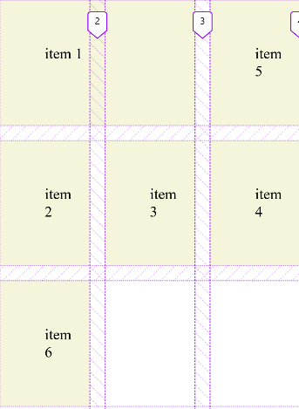

grid-row-end: 2;

grid-column-start: 1;

grid-column-end: 3;

grid-row-end: 2;

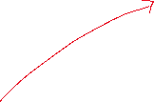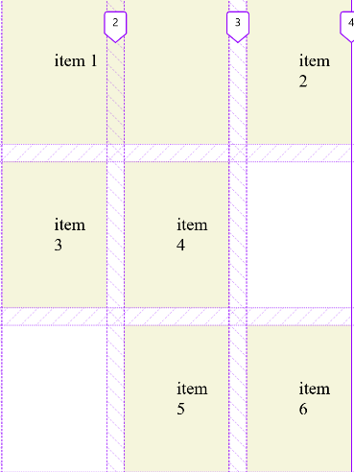

grid-row-end:3;

grid-column-start: 1;

grid-column-end: 3;

grid-row-end: 2;



If the item(5) comes before some items with no grid-row or grid-column, those items should come after it.

## Naming columns and rows

* **grid-template-columns**: **[col1-name]** 150px **[col2-name]** 150px **[col3-name]** // when you have two columns, you have three column names
  + **and for the grid item:** grid-column: col3 / col4, span 3
    - This sets the grid item to start at the grid line named col3-start, end at the grid line named col4-start, and span 3 columns.
    - grid-colum: col / col 3, span 3 // 1 is not require (col 1/col3, sapn 3)
  + To shorten the code: grid-template-columns: repeat(3, [col] 150); // repeat is supported in modern browsers. Repeat values cab auto-fit, auto-fill, integer
* **grid-template-rows:** **[row1-name]** auto **[row2-name]** auto **[row3-name]** // if the rows don't exist first you still can name them with this method
* grid-template-columns: **[col]** 150px **[col]** 150px **[col]** //

## Grid Area

* it makes the layout easier. You don't need to set columns and rows.
* Grid-template-areas: "col1 col1 col1" "col3 col4 col4"; // this says we have two rows ("") and colums have names.

grid-template-areas:

"header header header"

"sidebar content content"

"footer footer footer";

* grid-area: col1 //To use it, you just give the items the corresponding column names

.header{

grid-area: header;

}

.sidebar{

grid-area: sidebar;

}

.content{

Grid-area: content;

}

.footer{

grid-area: footer;

}

## Responsive with grid

* @media // mobile-first

// There is no need for columns since we only have one column in mobile applications

grid-template-area:

"header"

"sidebar"

"content"

"sidebar2"

"footer";

@media only screen and (min-width: 500px){

grid-template-columns: 30% auto; //two columns 30% and auto. Auto means cover the extra space

grid-containrer{

grid-template-areas:

"header header "

"sidebar content"

"sidebar2 sidebar2"

"footer footer";

}

}

## Fraction unit

* **grid-template-columns:** 200px 10% **auto** 20%; // there is no proportion between the columns. It manages space efficiently.

grid-template-columns: 200px **1fr 1fr 3fr**

grid-template-columns: 1fr 1fr 1fr 3fr

## Auto-fill and auto-fit unit

* It is usually a template column.
* **auto-fill** // based on the width given creates some cells(columns), and if the screen gets smaller, it automatically reduces the number of available cells.

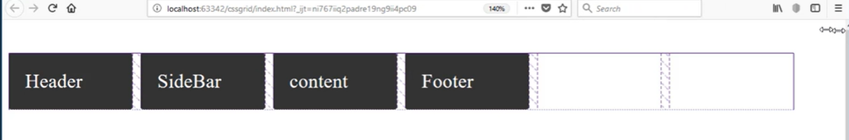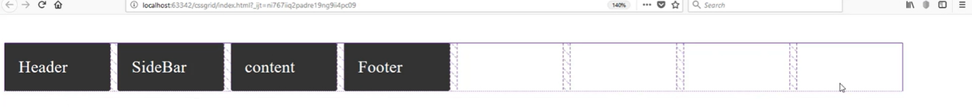

Grid-template-column: repeat(auto-fill, 150px);

* **minmax(minimum width, maximum width)** // using this method in template-column and repeat, we can have a more responsive layout. The width of the items changes based on need.

**Grid-template-column:** repeat(auto-fill, minmax(150px, 1fr));

* **auto-fit** // all the items will fit the whole screen based on the items' width.

Grid-template-column: repeat(auto-fit, minmax(150px, 1fr));

* How to put the footer at the end of the page? With this method, don't give bodies direct children CSS grid.

html{

height: 100%;

}

body{

min-height: 100%;

display: grid;

grid-template-row: auto auto;

}

Gap

* Not all browsers support this
* **column-gap: 20px** // between columns ( horizontally )
* **row-gap: 20px**

>ul{

margin: 0;

padding: 0;

display: flex;

width: 100%;

flex-direction: column;

justify-content: space-between;

column-gap: 10px;

@media screen and (min-width: 767px) {

margin: 0 -20px 0 0;

justify-content: space-around;

padding: 1.5em 0;

flex-direction: row;

}

@media screen and (min-width: 460px) and (max-width: 766px){

flex-direction: row;

// you need wrap to give item width effect

flex-wrap: wrap;

}

// the semicolon before should be here or li will not work

>li{

list-style: none;

padding: .3em 0.4em;

flex-basis: calc(25% - .8em - 10px );

flex-grow: 1;

background: rgb(192, 192, 192);

border-radius: 4px;

cursor: pointer;

@media screen and (min-width: 460px) and (max-width: 766px) {

flex-basis: calc(50% - .8em - 10px); // double the 0.4 right left

flex-grow: 0;

}

}

* only **column-gap: 10px;**

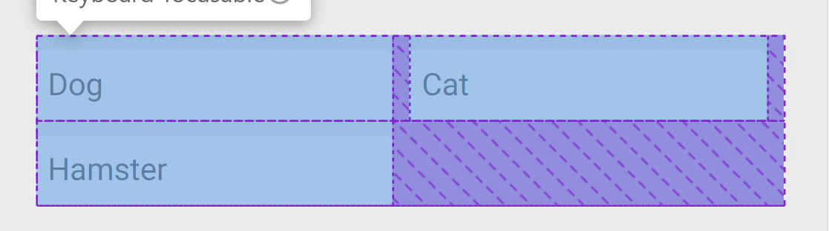

* **column-gap** and **justify-content: space-between**; with margin // the column gap will be used to create the space-between effect, which means just space between elements, and on the edges of the parent flexbox.

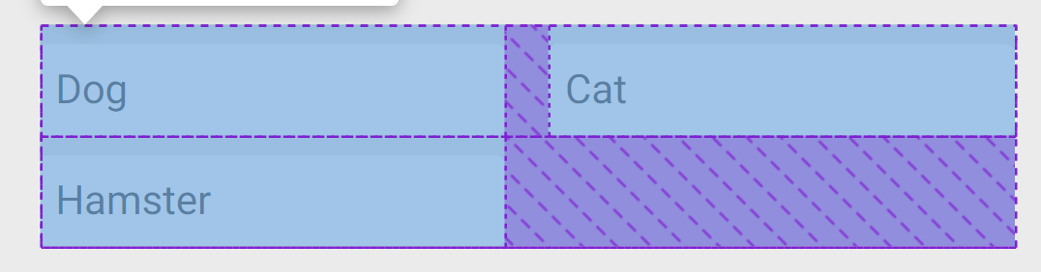



* row-gap without margin

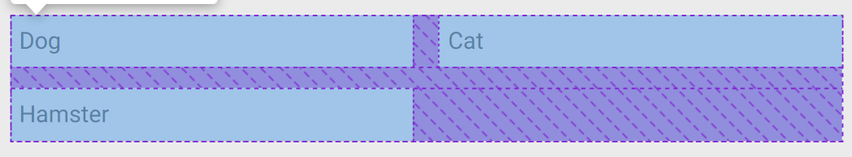

Calculations

* **cal()** // between minus and plus and numbers should be space

flex-basis: calc(50% - .8em); // double the 0.4 right left padding

Custom Properties

* --name // it is usually used as an arg for var() to set a value for other properties and defined in :root{}.

:root{

--container-padding: 20px;

}

var()

* The var() CSS function can be used to insert the value of a **custom property** (sometimes called a "CSS variable") instead of any part of a value of another property.